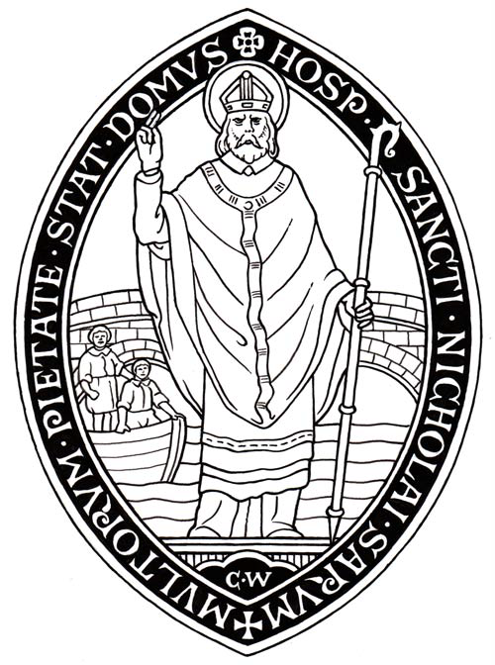

THE MASTER OF ST NICHOLAS’ HOSPITAL

INTRODUCTION

St Nicholas’ Hospital is an endowed Christian foundation established in 1215 which has provided unbroken service to people of limited means. The Hospital enjoys a riverside location with well maintained gardens just to the south of Salisbury Cathedral Close. There is a small and ancient chapel that is used for daily worship.

The Hospital provides accommodation in 24 self-contained flats (currently occupied by approximately 30 residents) principally to retired persons of good character in four small accommodation blocks. Residents of the Community are known as “Brothers and Sisters of St Nicholas’ Hospital”. The Hospital is governed by a small Trustee body, of which the Priest to Lead the Community (traditionally known as “the Master”) is an ex officio member. The Trustees are assisted by a part-time Clerk.

Further information is available on the Hospital’s website.

THE MASTER

St Nicholas is, first and foremost, a Christian Community and the Master is appointed to lead the Community. They should therefore have strong pastoral and administrative skills and empathy with the needs of the elderly. They should provide the Christian leadership and focus on worship which is the essence of the Community, although some of these leadership and administrative tasks are shared with other members of the Community. However, it is the ultimate responsibility of the Master to promote the Christian vision and ethos of the Community, having taken account of the views of its members in weekly meetings.

The present Master has made a priority of providing a pastoral ministry, and fostering open and supportive relationships amongst members, whilst recognizing the difficult balance between showing interest in each other’s affairs and respecting each other’s need for privacy. She emphasizes the need for reciprocity in relationships so that every member of the Community accepts responsibility for their own and each other’s needs.

DUTIES

The Master takes the lead role in the welfare of the Hospital and is responsible for the general supervision and pastoral care of the Community, responding to urgent issues as they arise. These may involve dealing with outside agencies on a member’s behalf or caring in the short term for members who are isolated in the Community or who lack family support.

It is important that the Hospital should remain fully occupied and the Master should use his or her best endeavours to make the facilities available at the Hospital widely known so that vacancies, when they arise, are kept to a minimum. When vacancies do become available, the Master will interview prospective new residents to assess their suitability before they are formally interviewed by a panel of Trustees. He or she will also recommend the allocation of accommodation.

The Master is the Chaplain of the Hospital and arranges the daily act of worship at 9.30am which should be attended by all members of the Community. Assistance in this is given by both retired priests and lay residents of the Hospital. Eucharist is the normal form of worship on Sundays and Holy Days. The Master takes the lead role in organising the special service and celebrations on St Nicholas’ Day (6th December) each year. Lay members of the Community provide voluntary sacristan assistance in Chapel services.

The Master is responsible for the oversight of the security and maintenance of the buildings on the Hospital site. Although assisted in this task by the Clerk, the Master should be comfortable with instructing contractors and other visitors to the Hospital site. Major works of repair and renovation are decided by the Trustees at their quarterly meetings.

STAFF

The Trustees have employed a Pastoral Assistant to the Master to provide cover on the Master’s day off each week and during leave.

The Master does liaise with and have the assistance of the part-time Clerk to the Trustees.

There are two excellent self-employed gardeners/handymen and cleaning of the public areas is also undertaken by a contractor.

ACCOMMODATION

The Master is required to occupy The Master’s House for the better performance of their duties. The Master’s House is part of the Old Building which also includes the Chapel, Common Room and some adjacent accommodation. The house is in good condition. It has four bedrooms, a large riverside garden and is offered unfurnished. It is occupied under a licence from the Trustees (as are all the residential units in the Hospital). Council tax and water charges are paid by the Trustees.

Adjoining the private accommodation (accessed either directly from The Master’s House or from the chapel via lockable doors) is an equipped study which is used by the Master and by the Pastoral Assistant on the days when they are working.

REMUNERATION

The salary offered is at a salary of £30000pa, subject to annual review by the Trustees.

The Master may join the Hospital’s NEST pension scheme to which employer and employee contribute, the employee’s contribution being at the rate of 4% of salary.

There is a total of six weeks paid leave each year, together with public holidays and a period for spiritual refreshment.

Telephone rental and official calls are paid by the Trustees. Any reasonable official costs incurred by the Master are reimbursed by the Trustees.

PERSON SPECIFICATION

Characteristics:

- Organised and a clear communicator
- Capable of easily forming good relationships with a wide variety of people
- Flexible – willing to work flexible hours as events and priorities require
- Calm
- Hospitable
- Committed to the promotion of the wellbeing of all
- Comfortable working alone and in a small team
- Open to the broad range of Christian traditions found in the Community
- Welcoming of lay leadership of worship

Experience:

- Experience of pastoral care, especially with the elderly
- Literate in the use of Microsoft Outlook and Word

GENERAL CONDITIONS

Standards of behaviour and conduct

The Master is expected to act at all times with due consideration for others, in a manner befitting their position as an employee of a charitable Christian community and in accordance with the Guidelines for the Professional Conduct of Clergy.

Health and safety responsibilities

The Master is required to ensure that they understand and accept the legal duties placed on them not to endanger themselves or others and to co-operate with colleagues and management in the control of health and safety at work and, therefore, in particular:

- to read and understand and abide by the Hospital’s health and safety policy
- to make themselves familiar with accident and emergency procedures on the Hospital site
- to make themselves familiar with the findings of any risk assessments which might affect them
- to inform the Chair of the Trustes immediately of any health or safety deficiencies or dangerous situations or near misses
- to set a good personal example in respect of health and safety

TERMS OF EMPLOYMENT:

Notice

The notice period is six months on either side or that to which the employee is entitled in accordance with current employment legislation, whichever is greater or by pay in lieu of notice by the Hospital. Should the Master be summarily dismissed on the grounds of gross misconduct, the employment may be terminated without notice.

Contract

The post is offered on an open-ended contract subject to
- a trial period of three months
- a current clear Disclosure and Barring Service certificate
- the licence of the Bishop of Salisbury (who is also the Hospital’s Visitor)

