
2026 Work plan
Alongside the Annual Safeguarding Report, please see the work plan for 2026 which can be viewed here: audit tracker

2025 Annual Safeguarding Report

This Annual Report of the Diocesan Safeguarding Advisory Panel (DSAP) covers the period January-December 2025 and is presented to Bishop’s Council and Diocesan Synod.

Safeguarding is not a discrete function of diocesan life; it is integral to our identity and mission as the Church. The calling to create communities that are safe, just and compassionate reflects the heart of the gospel and our responsibility to all who engage with our churches.

Our Safeguarding strategy is aligned with the five Safeguarding Standards set by the Church of England National Safeguarding Team: Culture, Leadership and Capacity, Prevention, Recognising, Assessing and Managing Risk, Victims and Survivors, Learning, Supervision and Support.

This report reflects a year of continued structural strengthening, cultural embedding and growing confidence in diocesan safeguarding systems, alongside important learning in response to challenges encountered.
CULTURE, LEADERSHIP AND CAPACITY
Church bodies have safe and healthy cultures, effective leadership, resourcing and scrutiny arrangements necessary to deliver high-quality safeguarding practices and outcomes.
Progress on INEQE Recommendations
Following the external audit undertaken by INEQE in 2024, we have continued to work systematically through the 33 diocesan recommendations. 20 of the recommendations have now been completed, with the remainder either in progress or embedded within wider project plans.
The audit emphasised the importance of safeguarding as a strategic priority rather than a parallel workstream. The adoption of the Director of Safeguarding role within the senior leadership team of the Diocesan Board of Finance has helped further cement the diocese-wide commitment to visibly have safeguarding as the golden thread running throughout all areas of work.

APCS data breach
During the summer of 2025, there was a data breach from our DBS provider, APCS, which significantly impacted operations, including the pace and direction of the DBS transition project to move providers. Whilst this caused unavoidable delays, it also highlighted the importance of:
- Clear lines of safeguarding accountability
- Robust data handling practices
- Trustee oversight and governance clarity - All PCC’s (and leadership teams in the Deaneries of Jersey and Guernsey) are charity trustees and therefore have responsibility for safeguarding within their parish/church.
The experience reinforced our commitment to supporting leaders and trustees to understand and fulfil their safeguarding responsibilities and the importance of their statutory and moral duties.

Diocesan Safeguarding Advisory Panel (DSAP)
DSAP have continued to ensure effective monitoring and oversight of safeguarding activities and have utilised an audit tracker to record progress on relevant reviews and audits. This year has seen consideration of the recommendations and learning points from the following:
- INEQE external safeguarding audit of the diocese of Salisbury (2024)
- Makin Report (2024) into the Church of England’s response to the abuse perpetrated by John Smyth.
- Scolding Report (2024) commissioned by Soul Survivor regarding allegations against Mike Pilivachi.
- INEQE national annual report (2025)
- Recommendations from the National Ministry Team regarding safeguarding in the Shared Discernment Process (2025).
PREVENTION
Church bodies have in place a planned range of measures which together are effective in preventing abuse in their context.

Prevention remains a key diocesan priority. Raising standards inevitably increases expectations and workload within parishes. Our focus has therefore been on ensuring that expectations are matched with practical systems and accessible support.

Parish Safeguarding Dashboard
The Safeguarding Dashboard (an online safeguarding compliance tool for parishes) continues to provide transparency and measurable compliance with Church of England and statutory safeguarding policies. When a parish first starts using their Dashboard, it begins at Level 1, and it can progress up to Level 3 by completing compliance actions. The increase from 22% of parishes at Level 3 in 2024 to 37.8% in 2025 demonstrates cultural embedding rather than simply a box-ticking exercise. Particularly well done to the 21 parishes who have completed and updated their Dashboards to 100%.

Parish Safeguarding Hub
The Safeguarding Hubs represent a significant step forward in simplifying safer recruitment processes and improving record-keeping. This online tool enables parishes to complete DBS checks with the new provider and record safeguarding training. Around 75% of parishes have signed up and have a Hub account; however, only 30% of accounts have started being used. Parishes have the significant task of transferring their DBS and training data onto their Hub and learning to use the new system. To support this transition, the Diocesan Safeguarding Team has introduced a new role of Parish Safeguarding Support Assistant, which has been funded as ‘surge capacity’ in response to the APCS data breach. These individuals were appointed in February 2026 for a period of one year and are available to meet with parishes and benefices in supporting them in setting up and using the new systems.

RECOGNISING, ASSESSING AND MANAGING RISK
Risk assessments, safety plans and associated processes are of a high quality and result in positive outcomes. The assessment and management of risk is underpinned by effective partnership.

Risk Register
During 2025, there was a growing awareness of the high level of risk associated with not having effective DBS processes in place across the diocese. Although the DBS transition project was already underway to mitigate these risks, several factors led to this risk appearing in the top three risks within the DBF risk register. Additional resources have been allocated to ensure the successful completion of this project and to mitigate against the risk of possible harm caused by Safer Recruitment failures.
Casework Activity
Here is a flavour of some of the work that the safeguarding team has been involved with this year:
- The Safeguarding Team recorded 230 new concerns on the casework managements system (compared to 212 in 2024 and 113 in 2023, which shows a 104% increase in two years). These concerns range from giving advice about best practice and prevention to responding when someone has suffered harm.
- There were 6 new Core Group processes that started, resulting from concerns being raised about Church Officers (there are 27 Core Groups currently ongoing).
- At the end of 2025, there are 33 former offenders who have active safeguarding agreements to attend church.
- 6 standard risk assessments have been completed.
This chart shows the nature of the concerns referred to the Diocesan Safeguarding Team:

 | No. of concerns | Primary nature of concern:
 | 6 | Adult safeguarding (sexual)
 | 9 | Child protection (Emotional Abuse)
 | 10 | Adult safeguarding (physical)
 | 11 | DBS
 | 13 | Domestic Abuse
 | 15 | Mental Health
 | 20 | Concerning adult behaviour
 | 22 | Child protection (sexual)
 | 132 | Advice
 | 11 | Other
The sustained increase in recorded concerns and an increase in safety plans reflect greater awareness, improved reporting culture and growing confidence in diocesan safeguarding processes.
Partnership working with statutory agencies remains strong and essential to effective risk management.
VICTIMS AND SURVIVORS
Victims and survivors experience the timeliness and quality of Church bodies' responses to disclosures, and their subsequent support, as positively meeting their needs, including their search for justice and helping their healing process.
During 2025, the Diocesan Safeguarding Team have been in contact with people who have experienced abuse in the following contexts:
- Where individuals have been harmed by someone who is a Church Officer, alongside assessing and managing risks, the Diocesan Safeguarding Team work with victims/survivors to ensure their experiences are heard, appropriate support and signposting are offered, and lessons are learned to improve practice.
- Individuals who are seeking an apology from someone who represents a Church Body, such as the Bishop.
- Individuals receiving funding from the Diocesan Board of Finance for therapeutic support.
- Individuals whose roles require them to complete safeguarding training, but who may find this traumatic due to the abuse they have suffered. The team have supported several individuals to complete their required safeguarding training in a person-centred and trauma-informed way.
The following feedback is from victims/survivors who have engaged with the diocese in the ways described above. Their words have been used with permission:
‘I felt welcome’
“The meeting was just the right balance between the personal and the formal… I did not feel rushed… Not for a moment did I feel patronised… Most of all it was a proper apology on the behalf of the Church of England. Not a corporate ‘we are sorry if you think that on this occasion our company failed to live up to the high standards we are known for…’ which is management consultant speak.
The fog has completely lifted today…Thank you again, I just wanted to reiterate how much your help has been appreciated.

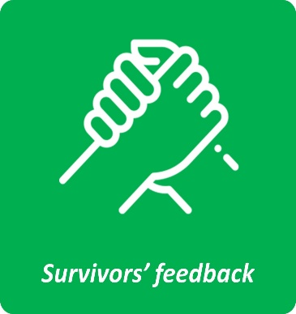

‘I was heard and believed’

Authentic Voice Panel
2025 has been a preparatory year in strengthening survivor engagement structures in anticipation of further national developments.

We have laid the groundwork for the establishment of the Salisbury Diocese Authentic Voice Panel — a forum where people with lived experience of abuse will actively contribute to shaping diocesan policy and practice. This reflects a commitment not only to consultation, but to meaningful participation.
Plans are also in place to embed a Survivor Champion role within the Diocesan Safeguarding Team. This role will advocate for, support and amplify the voices of victims and survivors within diocesan systems.
Alongside this, we are preparing to support parishes in the implementation of the national Redress Scheme, ensuring that victims and survivors are informed, supported and able to access the scheme with clarity and confidence.
LEARNING, SUPERVISION AND SUPPORT
All those engaged in safeguarding-related activity in Church bodies receive the type and level of learning, professional development, support and supervision necessary to respond to safeguarding situations, victims and survivors, and respondents, effectively.
Parish Safeguarding Officers (PSOs) remain central to safeguarding delivery. One of the highlights of the month for the Diocesan Safeguarding Team is meeting with around 50-70 PSOs for an online drop-in session. This new initiative involves training, development and support for PSOs in their vital front-line role. Training sessions are recorded and are accessible via the Diocesan Learning Hub.

This year, we have covered topics such as modern slavery, the role of the Local Authority Designated Officer, online safety for older people, and safeguarding when working with children and young people.

Feedback from participants attending safeguarding training during 2025:
"I am impressed by the training I have received for safeguarding & it is implemented by the Safeguarding Officer excellently within the benefice I serve”
“Really appreciated this training and its focus on culture and behaviour rather than compliance”

 | No. of courses | No. attendees
Leadership pathway | 40 | 458
PSO Induction | 6 | 41
PSO Workshop | 5 | 64

“In my preaching and interactions with members of the different congregations, it is important to model exemplary safeguarding behaviour but also to talk freely about safeguarding, ensuring it is seen as part of the culture of the church and not another burden imposed by the diocese. I hope that in many ways I have been doing this, but the course has strengthened my thoughts about this approach. “

“I always approach safeguarding less as a ‘set of procedures’ and more as a theological moral posture – an expression of justice, compassion and discipleship. This [training] has encouraged me to ensure my language is more invitational – not speaking of ‘compliance’ but rather of ‘creating safety’.”

Measuring the impact of training
For the past few years, we have continued to have consistently excellent levels of compliance for attendance at Leadership level safeguarding training for roles that we actively monitor and send reminders for (clergy, retired clergy with permission to officiate, and Licensed Lay Ministers), with 96.9% compliance. However, we currently do not have an effective system in place for oversight of safeguarding training compliance for courses aside from Leadership, or for roles other than those listed above, and with other roles within parishes. We also do not actively evaluate the effectiveness of training or measure the impact it is having on practice. Once embedded, the Safeguarding Hubs will provide oversight of training within parishes, and other projects aim to focus on the other areas we are currently missing.

During 2025, we asked everyone attending PSO workshops the question, ‘if you could describe the Diocesan Safeguarding Team in three words, what would they be?’ Here is what they said (words that appear larger were used more frequently):
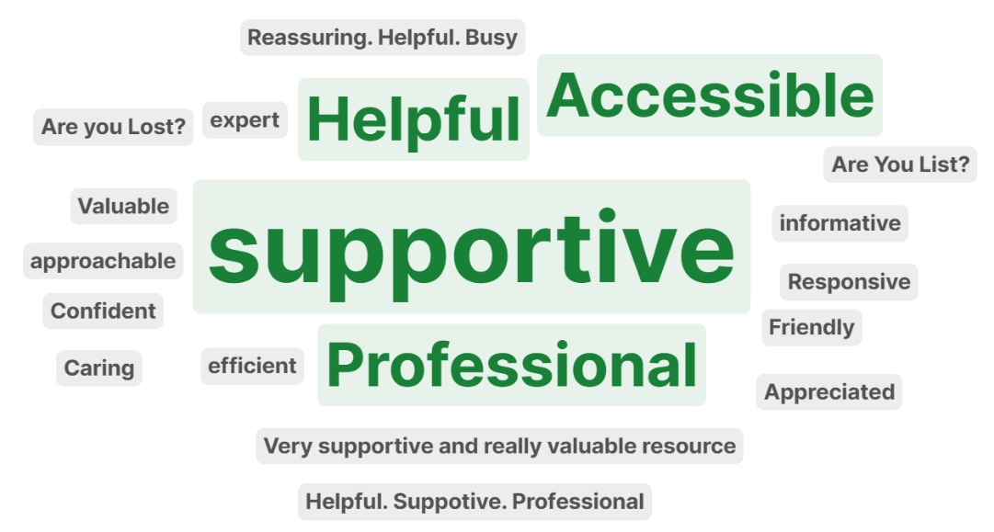

2026 KEY STRATEGIC PRIORITIES

Leadership, Culture and Capacity
- Further increase DBS compliance and support parishes in fully adopting Safeguarding Hubs
- Ensure clarity of safeguarding accountability among clergy, trustees and church officers
- Strengthen support, training and development pathways for Parish Safeguarding Officers
Victims and Survivors
- Establish the Salisbury Diocese Authentic Voice Panel
- Introduce and embed the Survivor Champion role
- Support implementation and promotion of the national Redress Scheme

CONCLUSION

2025 has been a year of steady structural strengthening. Systems have improved, and levels of oversight have deepened.

At the same time, the APCS data breach served as a sober reminder that safeguarding is inseparable from governance, data integrity and trustee accountability.

Safeguarding is not an administrative burden nor a reactive necessity. It is foundational to who we are called to be. It must continue to be the golden thread woven through leadership, ministry and mission.

Report written by Suzy Futcher (Director of Safeguarding)
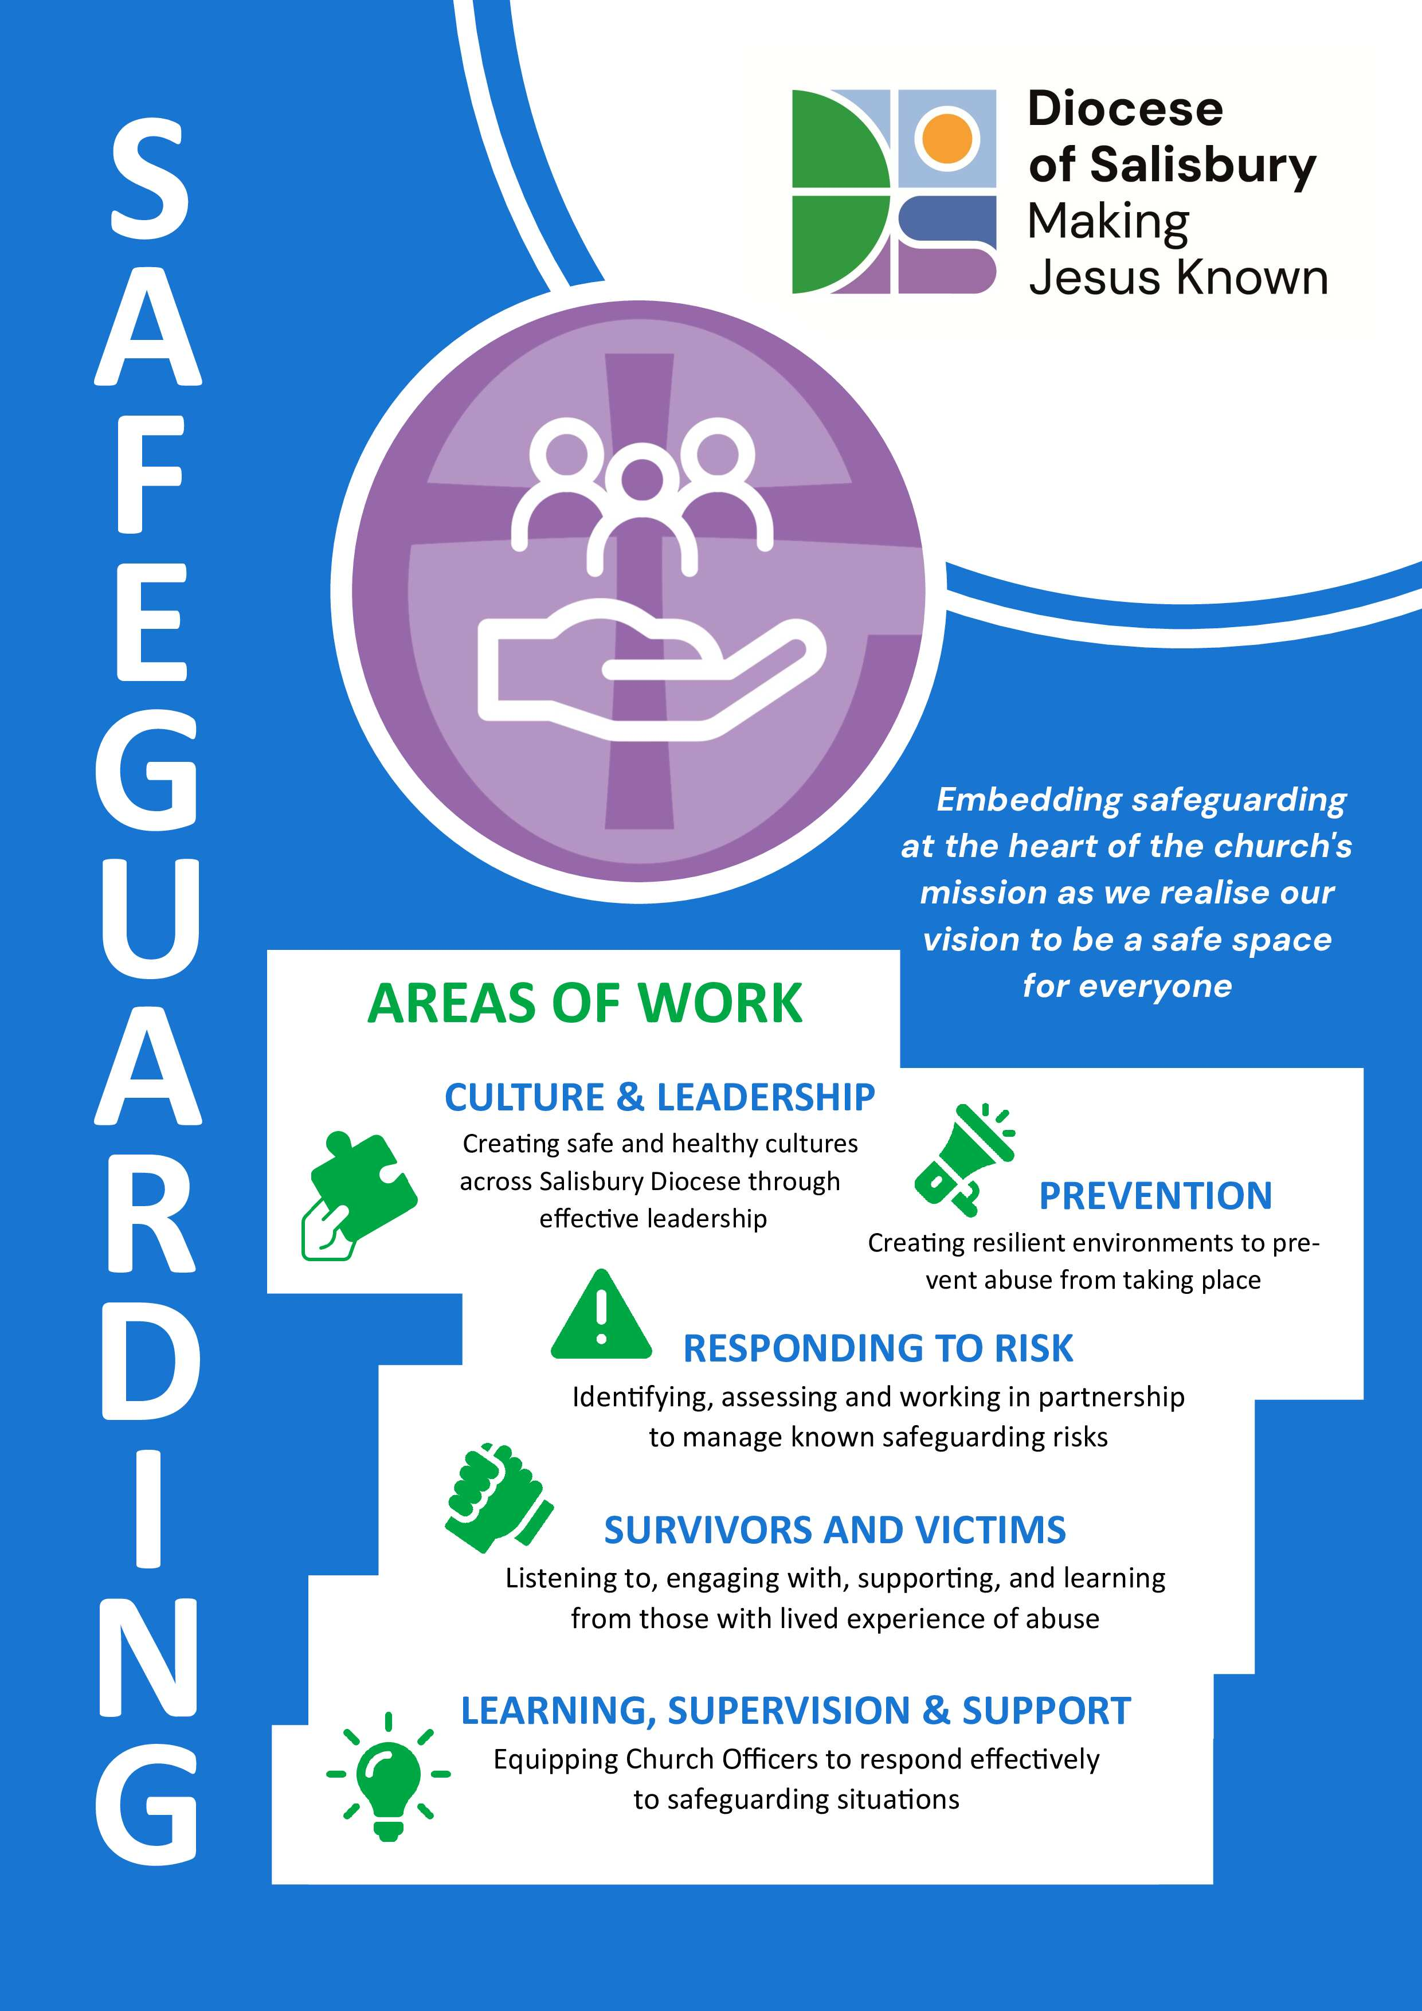
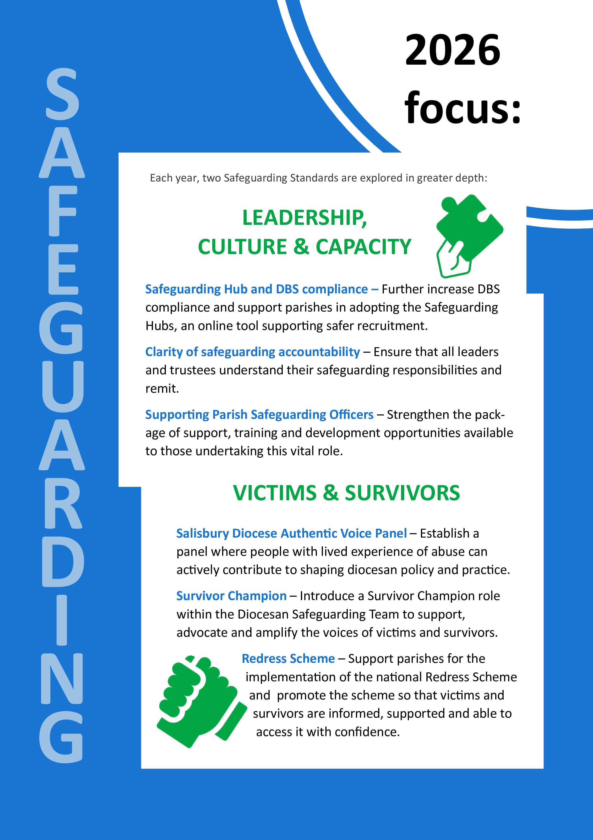

Parishes with 100% Dashboard rating – Bemerton, Bulford, Dilton Marsh, Glanvilles Wooton, Guernsey St Stephen, Hilperton and Staverton, Jersey St Clement, Jersey St Martin, Jersey St Martin de Grouville, Langton Long, Litton Cheney, Lytchett Minster, Monkton Farleigh, Semington, South Wraxall, St Aldhelm Purbeck, St John the Baptist Broadstone, St Mary’s Longfleet, St Paul Weymouth, St Peter Shafesbury, Stour Provost, Stratford Sub-Castle, Thornford and Winterslow.

