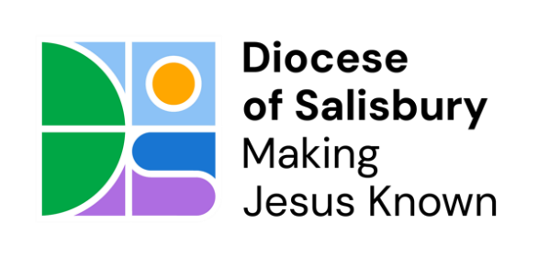

ROLE DESCRIPTION
Bishop’s Adviser on Climate Justice
In its vision to Make Jesus Known, the Diocese of Salisbury is committed to climate action, which forms one of its five substantive paths. Diocesan Synod passed a Net Zero action plan in 2023 and staff in the buildings team are resourcing work on net zero. A Growing Faith adviser is working with young people and parishes to develop their commitment to climate action, including encouraging participation in the Eco Church Award scheme. However, in the work to win hearts and minds there is need for a role which provides theological insight and leadership in parishes and across the wider diocese. This new and exciting role will offer that leadership and insight.
The role of a Bishop’s Adviser on Climate Action in the Diocese of Salisbury is to:
- provide support and suggest resources for clergy and laity
- Work within the climate action plan agreed and determined by the synod and managed by the DBF programme of work
- work with the Buildings Team and the Growing Faith Adviser and Communications team as required to develop the diocesan commitment to Climate Action
- encourage the diocesan eco champions network, building relationships and providing theological input and resource to parishes and individuals who form part of the network
- advise and inform the development of the diocesan approach to Growing Younger
- raise awareness and engagement of climate justice through preaching in churches across the diocese when available
- support the Mission & Ministry team to identify and deliver quality training to all curates, LLMs and ordained leaders to raise awareness, equipping them in their role
- be able to provide up to date information and advice for the Bishops of the diocese to equip them in their role, particularly in relation to the House of Lords and Church Commissioners
- be an advocate for the needs of specific groups of people and areas of ministry within the Diocese and its wider diocesan links with the Sudans, to ensure that, as a Diocese, we are committed to climate justice through all we do
- to promote the highest standards of safeguarding practice as it relates to the role
- represent the Diocese at relevant conferences and organisations as agreed/appropriate
Support and formation
The Bishop’s Adviser role will report to the Bishop of Salisbury, and one to one meetings to advise the Bishop will be arranged as needed, at least twice a year. The postholder will also sit within the wider Mission and Ministry team, with an expectation they will attend team meetings at least once a quarter to connect with work in the wider team.
With other Bishop’s Advisers, they will also attend the Bishop’s Leadership Team once a quarter.
Agreed hours
The role is combined with a stipendiary post with an expectation that 1-2 days a week will be spent on climate justice.
However, travel and reasonable expenses that are incurred as part of the Bishop’s Adviser role will be covered through the Mission and Ministry Team budget. Please talk to the Director of Mission and Ministry about any expenditure before a financial commitment is made.

Training
Individuals are encouraged to access further training/support that will equip them in their role.
In order to reflect the additional responsibility that an Adviser undertakes, it has been agreed that the CMD allowance for an individual is £500 per annum.

