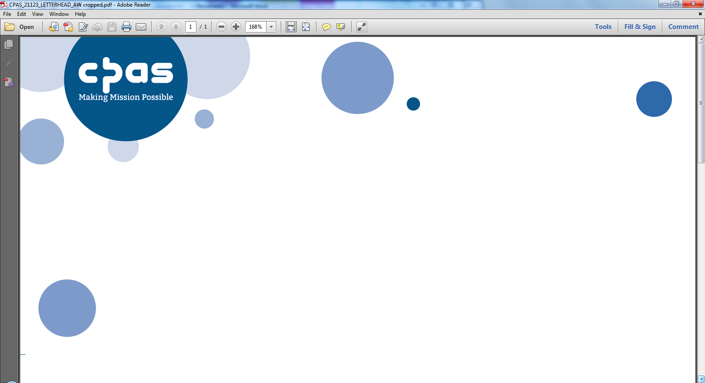

Sovereign Court One (Unit 3)

Sir William Lyons Road  
University of Warwick Science Park

COVENTRY

CV4 7EZ

02475 267843

patronage@cpas.org.uk

14 February 2025

**Rector, St Andrew’s Kinson**

**Diocese of Salisbury**

Thank you very much for downloading details of this post. I have pleasure in attaching a copy of the Benefice Profile and CPAS application form and any other relevant documents.

Please complete the application form. Please be aware that the CPAS application form does slightly differ from the standard Church of England application form for parochial posts. There is lots of guidance outlined within the form, so do take time to read the small print!

If you do decide that it is right for you to apply for this post, return the completed form, outlining what attracts you to this post in the personal statement within it. Do pay particular attention to how your gifts and experiences match the needs of the Benefice as outlined in the profile. **If sending in your application as a PDF please send me two separate PDF’s one the application and the other the confidential information.**

If you are appointed to this post you will be required to complete a DBS form so that a check at enhanced level can be made with the Disclosure and Barring Service

If you would like to discuss the profile further, or any of the background issues, please do not hesitate to contact me.

Yours sincerely

Dagmer Dias

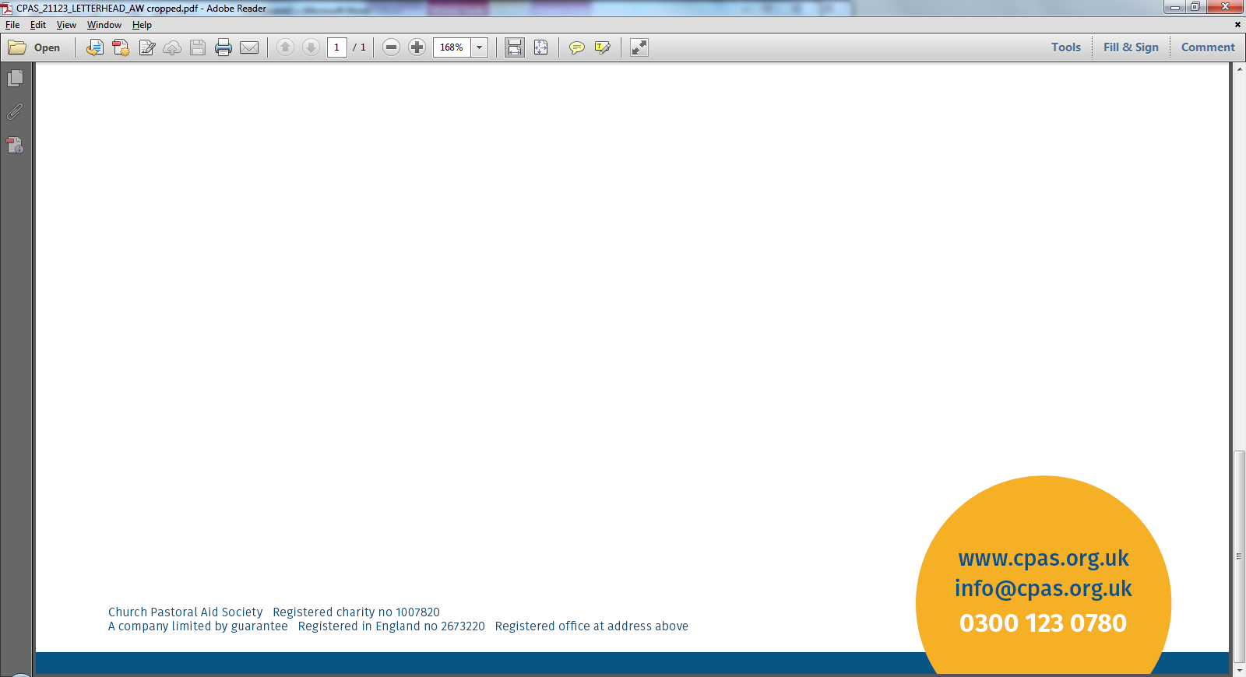EA to the Patronage Team