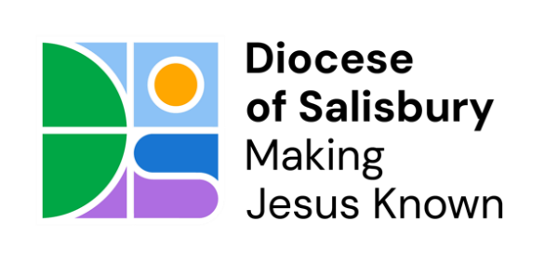

CHURCH ELECTORAL ROLL CERTIFICATE

Parish of:

in the deanery of:

I hereby certify that the number of electors upon the Church Electoral Roll of the above parish, as revised in preparation for the Annual Meeting held in the year 2025, was:

Date: Signed:

Please note that:

1) This certificate is to be signed by the chairman, vice-chairman, secretary, or church electoral roll officer of the parochial church council.

2) The number on the Roll should be sent to the secretary of the diocesan synod (the Diocesan Secretary) c/o parishsupport@salisbury.anglican.org by not later than 1 July.

If you’d prefer to post the form, please use the following address:
Salisbury Diocesan Board of Finance (SDBF)
Emmaus House, The Avenue, Wilton,
Salisbury SP2 0FG

