St Thomas’s House, St Thomas’s Square, SP1 1BA, 01722 333402, mothers.union@btconnect.com

DIOCESE OF SALISBURY MOTHERS’ UNION - JANUARY 2026

W I N T E R W I N D O W S

A MESSAGE FROM OUR PRESIDENT - SANDRA GAMBLE

As we enter 2026 and look to celebrate 150 years, I wish you all the best of years as members of this our outstanding global Mothers’ Union movement, now under the patronage of Her Royal Highness, the Duchess of Edinburgh, who is continuing the privilege of royal patronage since 1876.

There will be the national service at St Paul’s in London on 10 June and the Annual Gathering the next day at the Emmanual Centre. Some of you may travel to Durban, South Africa in October.

We in the Diocese of Salisbury have sent an expression of interest – a number felt achievable yet ambitious - to the 150th anniversary double National Challenges: to fundraise and increase our diocesan membership. And there’s our own service in Salisbury Cathedral to be led by Bishop Stephen Lake followed by a gathering hosted by Bishop Stephen and his wife Carol at South Canonry, both on June 13. More planning will take place as the year progresses.

However, as we come to the end of 2025, the first year of the 2025-2927 Triennium, I’d like to take a moment to remember some of what has happened since you received my previous Windows message in the Summer 2025 edition.

As you will recall, the recruitment and succession planning process in 2024 for a new MU Diocese of Salisbury Board took up most of that year. Fortunately, however, several current trustees agreed to stay on and one former trustee returned, so imminent dissolution of MU Diocese of Salisbury was avoided - although future succession planning does remain a concern. Bishop Stephen led the Triennium Commissioning Service on 31 July in the Cathedral’s Quire, banners were carried and lunch for members took place afterward in Sarum College’s Refectory.
Also, in the interests of diocesan sustainability, 2025 has continued significantly to be taken up with Salisbury’s participation in the SW Cluster Pilot. We are represented on the Cluster Steering Group by Trustee Carrie, Treasurer Suzanne and me, DP Sandra. Considerable personal time has been committed to development, particularly in attendance at and preparation for steering group meetings, my principal role being assistance in the drafting of legal documentation.

Late in the year, diocesan treasurer groups of the 8 participating southwest dioceses (Suzanne included) have also started to meet, to carry out diocesan due diligence (a big exercise) and, at the end of the year, treasurers have begun to consider training and are investigating, with the very recently appointed new central Director of Finance and Services, Sarah Salethorne, best banking options to meet diocesan accounts’ and branch accounts’ needs.

Although it was hoped that the new Mothers’ Union South West CIO (Charitable Incorporated Organisation), following the Charity Commission’s recommended Foundation model, would finally be in a position to “go live” at the beginning of January 2026 - three dioceses moving from their diocesan charitable status to being part of this new legal entity - financial issues are still waiting to be resolved with NatWest Bank. The issues have not been helped by the sudden unexpected departure in October of MSH’s serving Finance Director, Richard Miller. Salisbury’s members will have the opportunity in 2026 to vote on joining MU South West CIO. I am Salisbury’s nominee trustee to be appointed when the first of the three dioceses mentioned transitions.

Particularly, at a time when membership numbers are declining and volunteers for various posts are dwindling, we have been striving to support MSH’s strategic focus to counter this decline with MSH’s projects as well as our own. One such is MSH’s Church Based Membership Pilot. However, with the retirement of our Diocesan Chaplain (see below) we have not found the resource yet to appoint a Church Engagement Ambassador, which the project calls for. I am seeking to discuss appointment of a new chaplain with Bishop Stephen early in the new year.

Our diocesan projects continue to receive Trustees’ attention and commitment:
• Virtual Babies Life Skills project in 7 schools and starring, at the Canterbury Provincial
Gathering in Oxford in September, when Suzanne took an example baby north to
present our VB project as part of the southwest cluster’s presentations
• The 2025 AFIA season at our Rockley Park, 6-bed holiday home in Poole, Dorset,
particularly in memory of Sheila Soper, bookings run by Alison and helped by a
welcoming team led by Jill Beech
• The MU’s Angel Tree project at HMP Erlestoke, Harnham Branch, led by Liz Goater,
purchasing, wrapping and posting gifts to children of inmates - funding for the project,
should it continue in 2026, will require replenishing
• Rise Up! against domestic abuse – participation in the Bronze, Silver and Gold awards

On Saturday, October 18th, the Diocese AGM and Autumn Gathering took place at the Memorial Hall in West Moors, Dorset. Our speaker at the October Autumn Gathering was Trustee Jo Higgs who reported to members on the June Leadership Conference in Liverpool which she attended on behalf of the Diocese. Its themes were membership and the 150th anniversary celebrations.
Our annual 16 Days communion service, in support of gender-based violence and featuring our MU Souls of our Shoes display, took place in Salisbury Cathedral at 12 noon on Tuesday, 18 November. It was led by retiring MU Diocese of Salisbury Chaplain Jacqui Clark who also gave a heartfelt Address on the subject of domestic abuse. To mark her retirement, Revd Jacqui was presented at the end of the service with a MUe Mothers’ Union glass inscribed paperweight and flowering orchid.
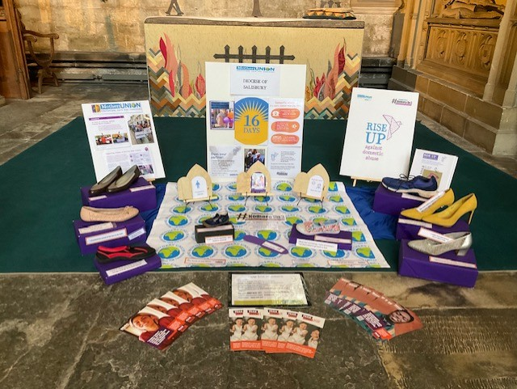
She left with our deepest thanks for coming back to take on the role of Chaplain for a second time following her service as Chaplain at HMP Erlestoke.
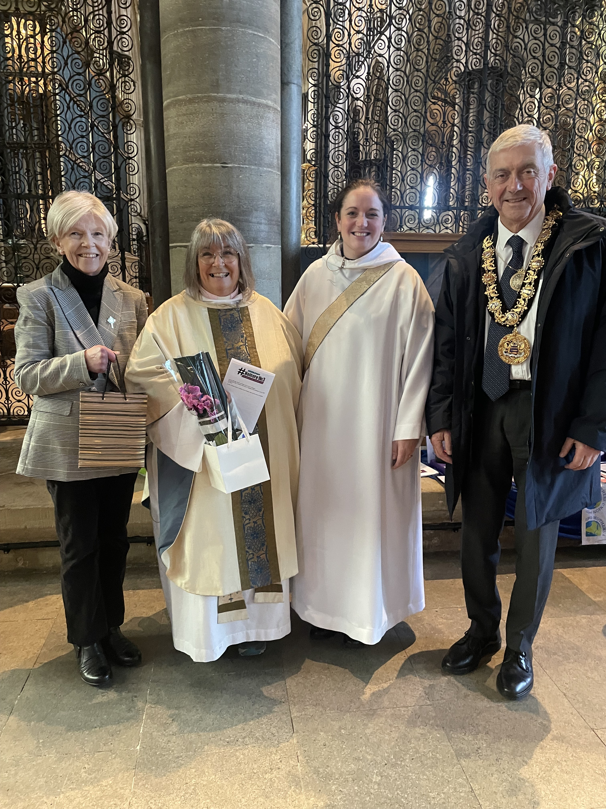

After the service, lunch for members and guests (including Salisbury Mayor John Wells who also attended the service) took place in Sarum College. As in previous years, an abundance of
donated items for Salisbury Women’s Refuge were brought by individual members to the service. (Please refer to the article below in this newsletter regarding SWR’s current distressing funding problems).

The year ended, for a second year,
with a MU Christmas tree at St Thomas’
Christmas Tree Festival, next door
to our central MU diocesan office.
Thanks go to members of West
Lavington Branch for setting up and
decorating the tree and to Laverstock
Branch for producing extra baubles.

Wishing you all a very blessed and happy
new year.
Sandra
Salisbury Women’s Refuge – as a funding crises hits the 150-year-old Refuge

Sandra asks that we pray for the future of Salisbury Women’s Refuge as it makes an appeal in the face of a very real threat of closure. The issue is lack of financial stability following Wiltshire Council’s decision to stop providing funds directly to the Refuge and the subsequent failure recently, after a yearlong negotiation, to reach terms of merger with You Trust.

This has left the Refuge operating without dedicated domestic abuse funding for the past three years, receiving just basic housing benefit as a landlord, and now facing closure due to these funding issues.

As reported on the BBC, Caroline Probert, chair of trustees at the Refuge (and a Mothers’ Union appointed trustee to the Refuge), says: "We've reached a point where we have to do something dramatic. Financially, things are really quite tight and the support we offer to women needs to be stable.

We have women from quite a range of backgrounds. The majority are in the younger age group, but this isn't exclusive. They come with fairly minimal possessions, often just what they can carry.

Women who come to a refuge can self-refer but also can be referred to by organisations such as the police, social services or housing departments.

Sometimes they have left situations which are really quite dire or even life-threatening. It can all feel quite raw. We help women get back to feeling normal and that they can participate in society."

Although Caroline adds: "The response so far has been astounding, I know we're rock solid for at least the next month or two”, the Refuge hopes to be able to raise £20,000 to continue its support in the coming months.

Our MU Trustees will be discussing the nature of any support Mothers’ Union in the Diocese can provide or suggest at the next Trustees’ meeting on 15 January. Please email Tracy to contribute any ideas you may have.

CHAPLAIN’S CHAT

A Year of Gratitude and Hope

As I come to the end of my year serving as Chaplain to the Mothers’ Union, I do so with a heart full of gratitude. It has been a privilege to walk alongside you in prayer, worship, and fellowship, and to witness first-hand the faith, compassion, and commitment that define this organisation.

Over the past year, I have been continually encouraged by the quiet faithfulness of the Mothers’ Union—by your care for families, your support of communities, and your dedication to prayer and service, often carried out behind the scenes. These are not small things; they are powerful acts of love that make a real difference.

I would especially like to thank and encourage our hardworking trustees. Your leadership, wisdom, and perseverance sustain the work of the Mothers’ Union and help it to grow and adapt for the future. The responsibility you carry is significant, and your dedication does not go unnoticed. Please take heart in knowing that the seeds you are planting now will bear fruit in ways you may never fully see.

As I step away from this role, I do so with confidence in the future of the Mothers’ Union. May you continue to be strengthened by God’s guidance, united in purpose, and renewed in hope as you move forward together.

Thank you for allowing me to share this season with you. It has been a blessing I will always treasure.
Jacqui
TREASURER’S NOTES

As I close another year of accounts, I am very aware that due to the ongoing reduction of our membership, we are now moving into an era of not covering our annual expenditure with our annual income; subscriptions being the largest part of our income. We do currently hold good reserves to bear the overspend but for how long will these last.

With me, trustees are looking closely at where we can make savings, the running of the office is our highest cost. Trustees will decide on the increase of our subscription for 2027 early in the new year. We will have to increase it, and sadly this will probably lead to some members cancelling their membership, as I have seen in the past.

Branch treasurers, please do not forget to ask and tick the new box on your branch subscription form for 2026, regarding paying by Direct Debit.

Finally, I am still your treasurer, as to date, we have had no interest in our pleas for a replacement, we will once again make a concerted effort in the new year. If you know/hear of anyone you think might be interested, please do contact me.
Suzanne

NEWS FROM AROUD THE DIOCESE

St Mary’s Dorchester
I am Katharine Marr and by the time you read this I shall be 97 (22/10/1925). I joined the Mothers’ Union when I retired from teaching and could come to afternoon meetings at St Mary’s Dorchester. My mother May Marr was also a member. Together we became Literature Representatives for the deanery. We would give talks on the Literature available at Church House.

I became a speaker. I think in those days there was a set theme for speakers. I can remember taking a lovely picture of a field and stream to accompany our talk on child education. I believe in active participation in my talks and give out marked passages for members to read out. One very popular talk I gave was about T-cakes. I pointed out that people are not alike and compared them to cake ingredients. At the end I produced a cake for consumption. I can remember another talk which started with Mary at the tomb at Easter (with suitable readings) followed by Easter customs and finished with us all singing Easter bonnets. I became Enrolling Member of St Mary’s but as the members were elderly the numbers shrank and eventually the branch was closed. The P&F branch still flourishes.

Now I am nearly 97, I still live in the same house relying on helpful neighbours and receive Communion at home. I have sight and mobility problems but still write for the parish magazine. There is a lot I have left out; maybe others younger than I will remember more.

Wilton
We have had a colourful season this year, starting with our lovely 'tropical flower' headdresses, worn as part of the World Day of Prayer service which originated from the Cook Islands. Throughout the following months we knitted baby blankets in pastel colours and must by now have gone well over 500 full sized blankets plus smaller crib sized ones assembled from squares. We also used brighter colours to make the AFIA teddy bears for this summer's holiday. We had a wonderful outing to Cranbourne Manor Gardens, enjoying the beautifully planted beds in the white rose garden, the purple garden and the wildflower meadows with their drifts of white moon daisies and tiny mauve meadow orchids. We also looked at the church next door to see the intriguing wall paintings and take heed of the message of the Seven Deadly Sins (although 'Gluttony' did not deter us from enjoying afternoon tea afterwards!)
Christine Matthews, Wilton MU Admin
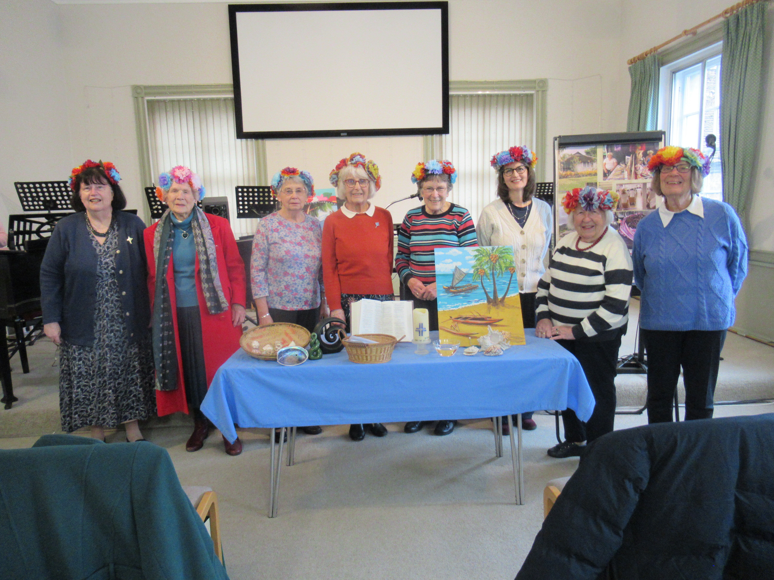

dd

Colehill
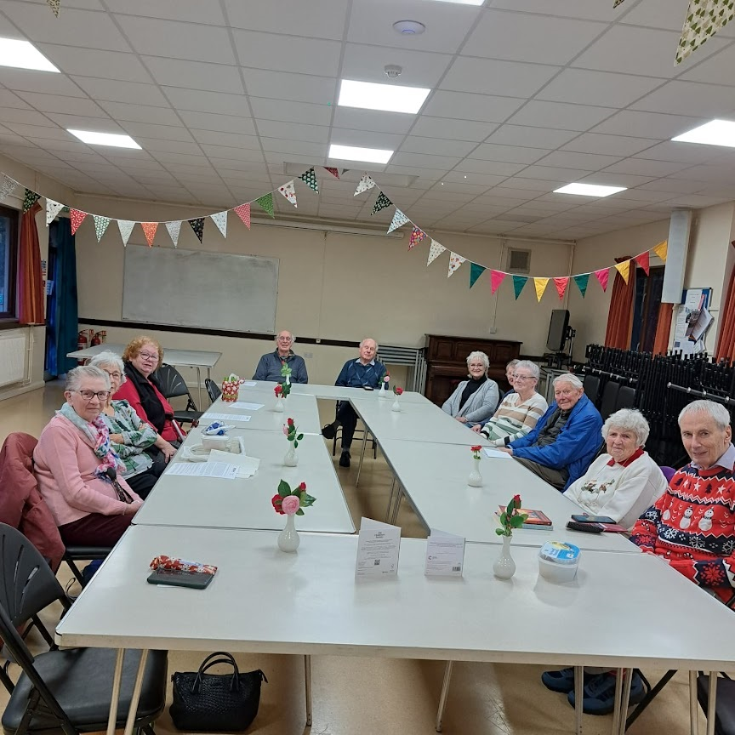
Members enjoyed a
lovely tea after readings
by Margaret Gillingham,
Mac Chisholm, Hilary
and Alan Motson.

Laverstock
Approx 70 people of all ages supported Laverstock’s annual garden party – some had no previous connection with MU or the church. It was a very relaxed and happy occasion.

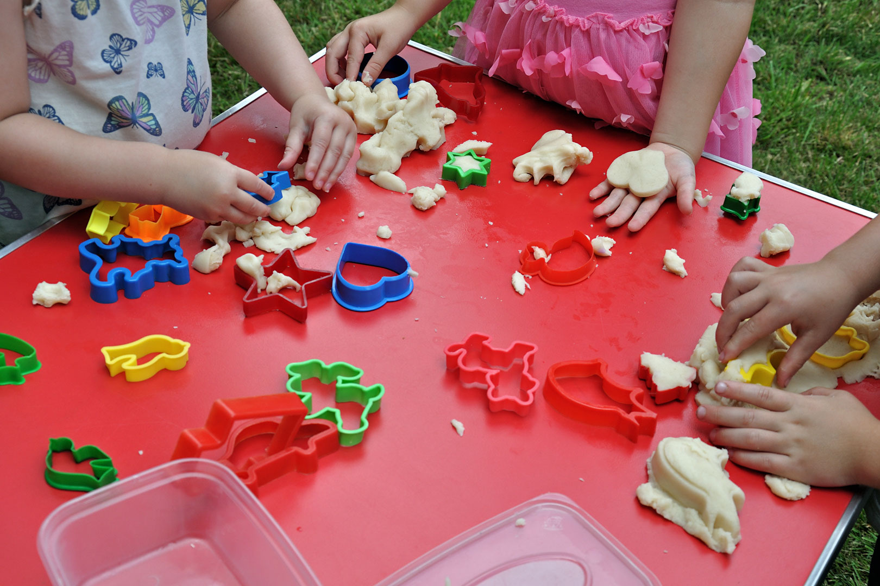
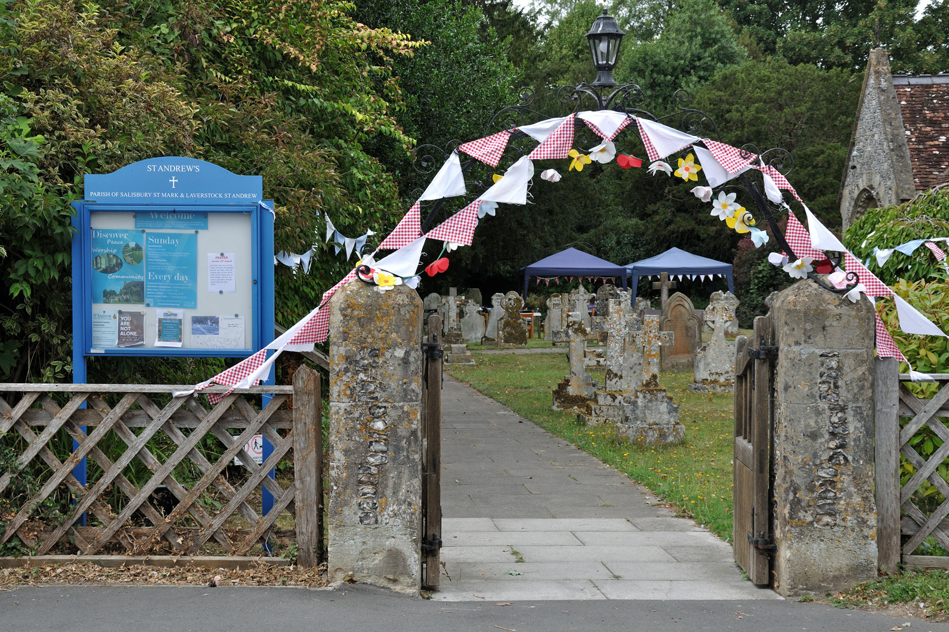

Dilton Marsh
On 7 August we held a Cream Tea at Holy Trinity Church in Dilton Marsh. This was in aid of the MU Summer of Hope appeal. A friendly crowd from Dilton, Westbury and Beckington MU, along with local friends, enjoyed the wonderful tea and generous raffle to raise over £400 towards this worthy cause. A display showed the varied work of the MU in this country and around the world.

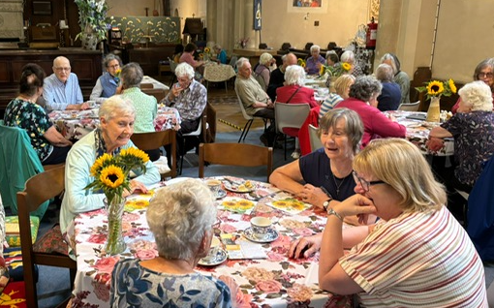

c

Holy Trinity with Christchurch, Bradford on Avon
At one of our recent meetings, we had the pleasure of welcoming Julianah Ajayi, a Mothers’ Union member from Nigeria. Julianah was staying in Bradford on Avon as a guest of one of our members, Jill. Here’s the story of how the two friends met in 1995.

The two members met in Birmingham in 1995. Birmingham was linked with the Oke-Osun Diocese in Nigeria. Julianah and the Bishop at that time, Bishop Abraham, visited Jill in Birmingham and the Bishop invited her and her family to stay with him in Nigeria. The family accepted that invitation and stayed with him whilst attending a family wedding there. While in Oke-Osun, Jill visited the Mothers’ Union where Julianah was leading a MU project of
making soap to generate income. The following year, Julianah was sponsored by the MU to do a year’s course at the College of Ascension in Women’s Leadership in the Church in Birmingham. Jill worked at the college and they became very good friends and have kept in touch ever since. Julianah returned to England this year to visit her son in Manchester and of
course, took the opportunity to visit her friend in Bradford on Avon.
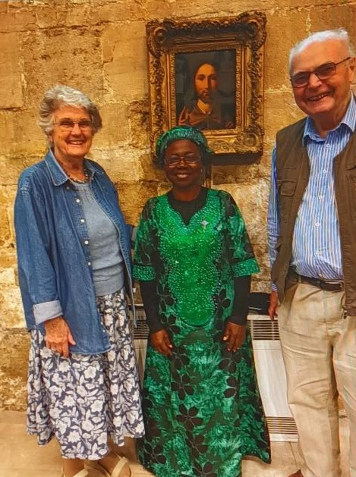
What a happy, informative and colourful meeting
we had and what a lovely story of friendship through
our worldwide Mothers’ Union.

Julianah with
Jill & her husband
pictured at our meeting
in Holy Trinity Church

Sturminster Newton
Farming Community Network. Our Sturminster Newton Mothers’ Union read an article in Connected Spring 2024 about members in the Lichfield Diocese knitting hats to help farmers in rural communities. This inspired our small group of only 5 members to do the same. Farmers are more than three times likely to commit suicide than the national average. Our photo shares the hats that were knitted, each having a helpline number sewn into the hat, enabling farmers to ring if they need to talk to someone. The FCN (Farming Community Network) provides counselling for farmers and help with finances. We are distributing the hats via a church in our benefice, St Thomas’ Lydlinch, who have a link with the Farmers’ Union and local farming community.

Wriggle Valley Prayer and Fellowship Group
We are a small group who meet once a month for prayer and sharing. We have just held a Soup lunch which has raised £300 which we will donate to The Women's Refuge and one of MU charities.
Anne Reason

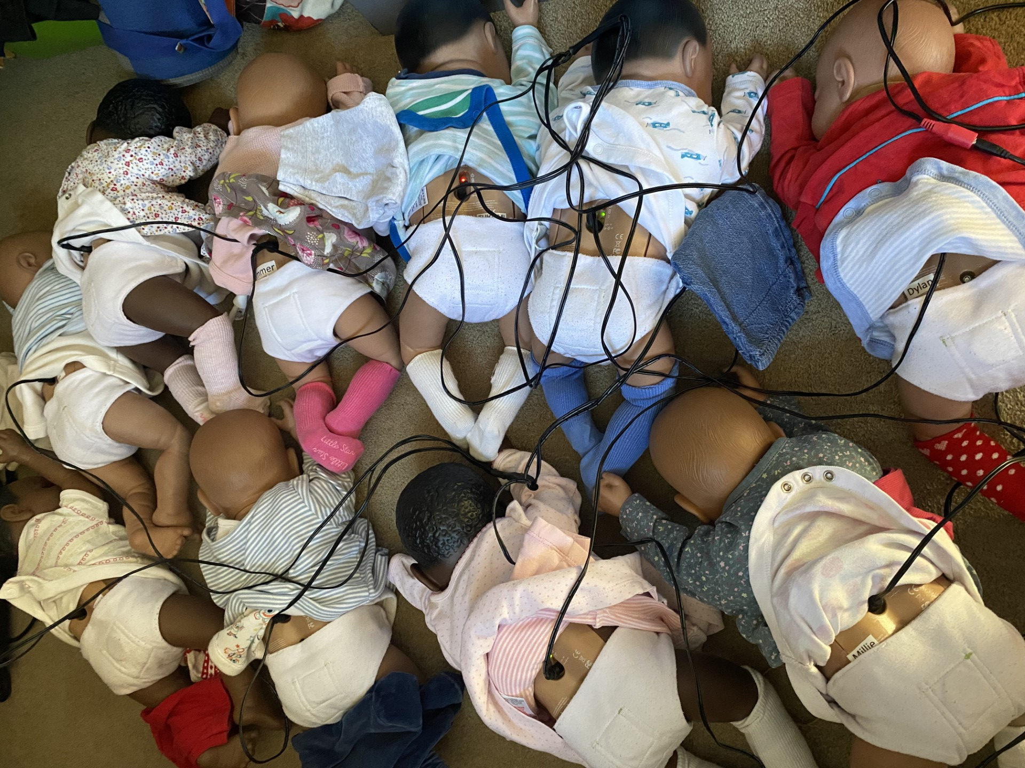

VITUAL BABIES

Charging them up ready to take to Matravers school on Monday 5th January.

MU SHOP
At the AGM the shop made its final appearance. In future all we will keep in stock will be badges and membership cards. The remaining cards etc. will hopefully find purchasers in the coming months and if they don’t sell we’ll donate them elsewhere. It’s sad, but inevitable, that this has happened. If you are buying anything direct from Mothers Union in London or online please remember to write Diocese of Salisbury on your order so we can receive a percentage of the money you paid.

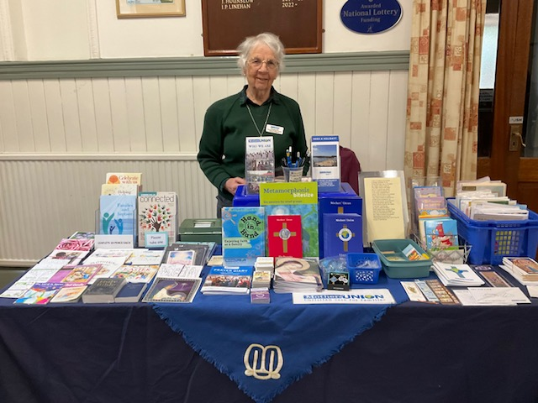

IN MEMORIAM

Evelyn Grant All Cannings Joyce Hubert Guernsey Rosemary Murphy Diocesan June Morris Shrewton
Beryl Diamond Wilton June Leaper Wareham
Christine Ryder Blandford Forum, Harnham Marian Booth Diocesan
Madeline Tarrant Diocesan Mary White Wareham

DATES FOR YOUR DIARY

Trustees meeting 10.00 am,15 January 2026
St Paul’s Service 5.00 pm 10 June 2026
Cathedral Service 11.00 am, 13 June 2026. To celebrate 150th anniversary of MU led by
Bishop Stephen followed by a gathering in the South Canonry.

Please send news for the Spring edition of Windows to Mrs Elizabeth Goater, 17 Chiselbury Grove, Salisbury SP2 8EP. Tel: 01722 433855, or best by email: lizgoater@hotmail.com. before 16 April 2026.
Please send pictures and photos in a separate file and not as part of the article.



