Hub Lead Practitioner | Katy Thomas | Jo Needham | Amanda Hodgson & Sophie Bales | Helen Cooke & Vicky Bunting | Steph Rann | Hazel Baines  & Trevor Willis | Trevor Willis & Shelley Jones
Email address | k.thomas@ashtonkeynes.wilts.sch.uk | Joanne@woodborough.wilts.sch.uk | ahodgson@longford.wilts.sch.uk  sbales@stnicholas.dsat.org.uk | HCOOKE@durrington-jun.wilts.sch.uk  BU@kingdown.wilts.sch.uk | stephanie.rann@gryphon.dorset.sch.uk | Hazel.baines@salisbury.anglican.org  twillis@st-edwards.poole.sch.uk | twillis@st-edwards.poole.sch.uk  shelley.jones@kingsleighprimary.co.uk
Name of the group | WILTS 1  Wiltshire North & Central (west) | WILTS 2  Wiltshire Cent. & Northeast | WILTS 3  Wiltshire South & East | WILTS 4  Wiltshire South & West | DORSET 1  Dorset North & West | DORSET 2  Dorset Central & East & South | BCP 1  Bourn’mth Christ- church & Poole
Hub Lead Practitioner school contact details | Ashton Keynes CE Primary  Gosditch, Ashton Keynes Wiltshire  SN6 6NZ  01285 861436 | Woodborough CE VA Primary  Broad St., Woodborough  Pewsey SN9 5PL  01672 851305 | Amanda: Laverstock St Andrew’s CE VA Primary Church Rd., Laverstock  Salisbury, SP1 1QX  01722 503590 | Vicky:  Kingdown School  Woodcock Road, Warminster  BA12 9DR  01985215 551 | Steph: Sherborne The Gryphon School  Bristol Road  Sherborne  DT9 4EQ  01935 813122 | Trevor: Poole St Edwards School, 67 Dale Valley Road, Poole BH153HY  Hazel: 01725 517439 | Shelley: Kingsleigh Primary School, Hadow Rd, Bournemouth, Dorset, BH10 5HT  01202 528893
Approx Area | Swindon | Marlborough | Salisbury | Warminster | Sherborne | Dorchester | Poole
Dates of meetings  If you can’t attend your local one, please go to any other. | Please email Katy for links. All meetings are online.  Tuesday 12th November  Monday 24th March  Tuesday 17th June | Thursday 28th November 4-5.30pm at Bishops Cannings Primary School SN10 2LD | Monday 18th November 4-5.30pm at St Andrew’s Primary School in Laverstock SP1 1QX | Thursday 28th November 4-5.30pm at The Minster Primary School in Warminster BA12 8JA | Tuesday 12th Nov 2024 – 4-5.30pm at Sherborne Abbey Primary School DT9 6AQ | Tuesday 12th November at St Mary’s Middle School, Puddletown DT2 8SA | Tuesday 3rd December at Kingsleigh Primary School, Bournemouth BH10 5HT
 |  | Thursday 1st May 4-5.30pm at Woodborough Primary School Broad St., Woodborough  Pewsey SN9 5PL | Monday 19th May 4-5.30pm at St Nicholas’ Primary School in Porton SP4 0LB | Thursday 1st May, 4-5.30pm at Westbury Leigh Primary School, 49 Sandalwood Road, BA13 3UR | Tuesday 29th Apr 2025 – 4-5.30pm at St Mary the Virgin Primary School, Gillingham SP8 4LP | Tuesday 29th April 4-5.30pm at Puddletown St Mary’s Middle School, Coombe Road, Dorchester DT2 8SA | Tuesday 6th May 4-5.30pm at Kingsleigh Primary School, Hadow Rd, Bournemouth, Dorset, BH10 5HT
Virtual Wiltshire LA Subject meetings: | Wiltshire are offering short, virtual ‘RE Subject Leader input’ led by RE advisers or Hub Leaders. On Monday, 7 October, Tuesday, 28 January 2025 and Wednesday 04 June 2025. (Time: 15.45 – 16.45) You can book your place, by clicking on the dates. Please note that the meetings are not recorded. Don’t have a Right Choice Login? Email rightchoice@wiltshire.gov.uk (stating you wish to book RE Subject Leader Network virtual course)
Teaching RE to KS3+ or SEND? | A virtual KS3+ network for Middles and Secondary schools and academies is planned. Please email stephanie.rann@gryphon.dorset.sch.uk to be sent details. If you are an RE teacher in a school that specialises in SEND please contact Vincent Saunders at v.saunders@winchelsea.poole.sch.uk
Any Questions? Contact your Network Hub Lead Practitioner or Nicola Coupe Nicola.coupe@salisbury.anglican.org


Dates for your Diary –
The CREative, REinspiring, Virtual RE Conference on Wednesday 26th March 2025. This highly enjoyable virtual day conference is put together by a working party from all 3 SACREs and with input from RE Advisers from Wiltshire, Dorset and BCP and from Salisbury, Bristol and Winchester and Portsmouth dioceses. This year’s theme is Putting People First. And a timetable is below.
The conference is focused on providing Creative approaches to teaching in schools. It covers EYFS to A Level. The cost of a ticket is subsidised through a grant from Sarum St Michael’s Education Charity and therefore costs only £60 per attendee including VAT. This entitles you to access recordings of workshops and course materials for 10 months. Not to be missed! Book Here (Schools signed up to Salisbury Diocesan PSA or PCSF have already paid and will have been sent a coupon code - so you need that in order to book at no additional cost.)

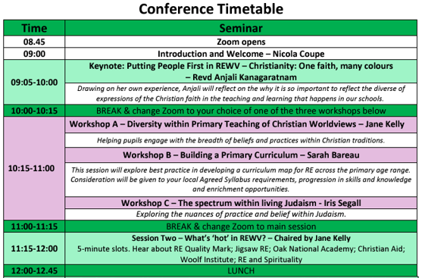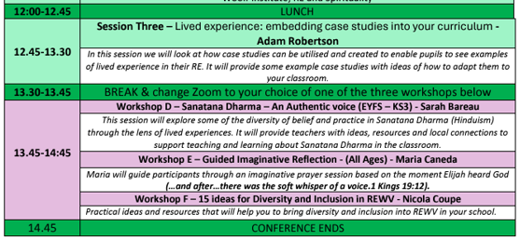

Useful local website pages for SACRES and dioceses serving this area:
- Wiltshire Right Choice – RE pages and SACRE information https://rightchoice.wiltshire.gov.uk/Search?search=relig
- BCP SACRE https://www.bcpcouncil.gov.uk/Schools-and-learning/SACRE/Standing-Advisory-Council-on-Religious-Education-SACRE.aspx and BCP Locally Agreed Syllabus from September 2023 here.
- Dorset SACRE’s webpage is being launched this autumn and will host the Dorset Locally Agreed Syllabus which is new for January 2025 and is based on the BCP new one. The current syllabus is here: https://d3hgrlq6yacptf.cloudfront.net/62d6c0328cf55/content/pages/documents/dorset-agr-syll-for-re-2016-final.pdf
- Salisbury Diocesan Board of Education RE and Collective Worship pages https://www.salisbury.anglican.org/schools/worship-spirituality-rhse/
And School Leader Updates that always contain a section on RE and Thought for the Week which may be useful for Collective Worship.
- Bristol Diocesan Board of Education RE pages https://www.bristol.anglican.org/education/schooleffectiveness/reresources/
- Winchester and Portsmouth Diocesan Board of Education https://www.portsmouth.anglican.org/education/
- Learn Teach Lead RE https://ltlre.org/
RE Advisers: Laura Harris Laura.Harris@bristoldiocese.org Dave Rees david@reesuk.onmicrosoft.com Jane Kelly jane.kelly@portsmouth.anglican.org

