Wareham Team Ministry

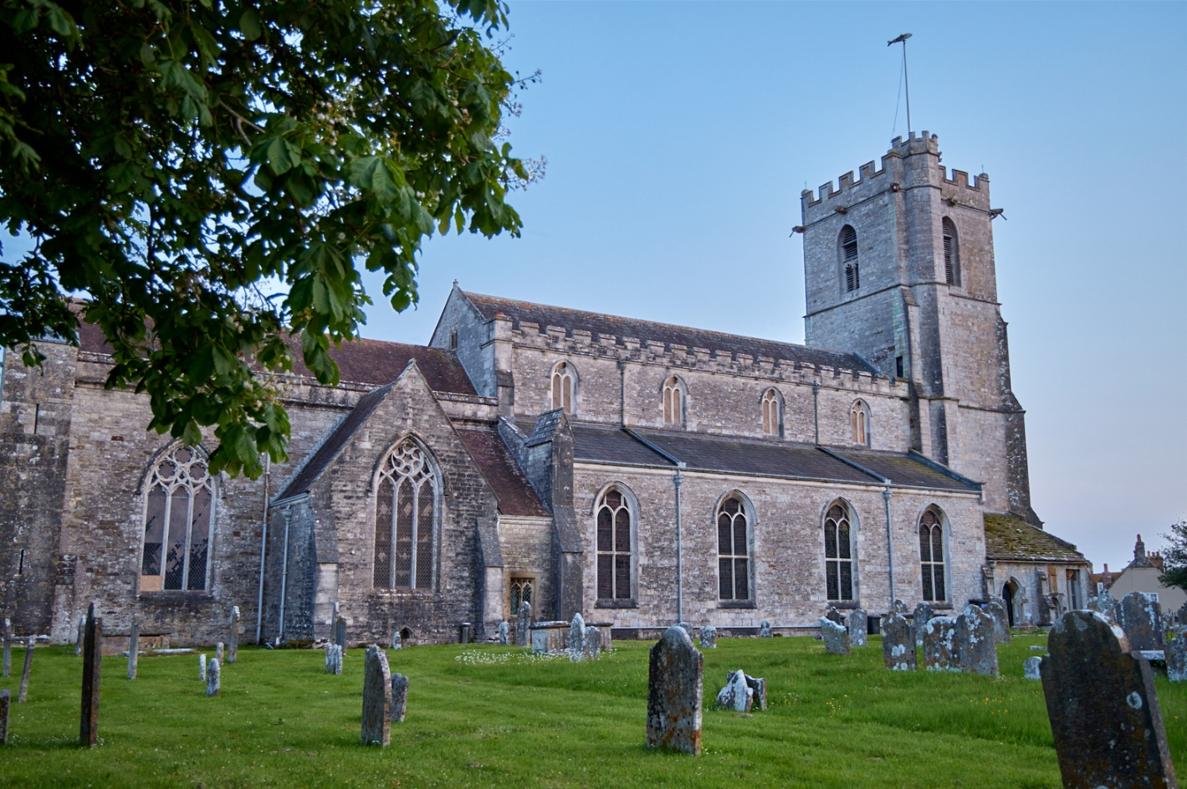

Parish Profile for the post of
Team Vicar - June 2023

Our Parish Vision

Our vision is to show God’s love and make Jesus known in our community. We seek to do this by growing as disciples of Christ, reaching out in the power of the Spirit to serve those in need and feeding on God’s word as we share in fellowship together.

Welcome!  We are delighted that you have taken the first step in exploring the possibility of being our next Team Vicar. The following document has been compiled to help you in your discernment process. It will give you some idea of the diverse mission opportunities there are within the different communities of this parish, and at the same time outline the sort of priest we are looking for to work with us in moving forward. | 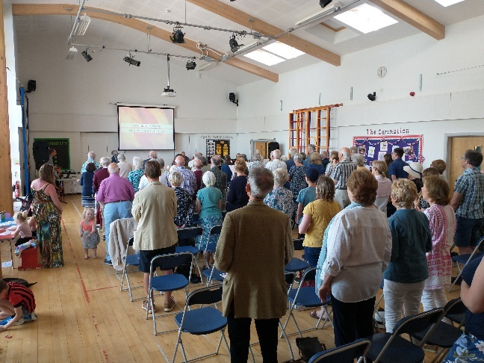
From the Bishop of Sherborne
This post offers an excellent opportunity for the right candidate to bring their own skills and gifts to a welcoming, and lively Team.
The parishes in the Wareham Team enjoy a good location with access to the Isle of Purbeck, the edges of Poole harbour and not far from the sea. The town of Wareham and surrounding villages have a welcoming feel with newcomers, long standing residents, and visitors all feeling at home and the churches set in key positions and playing important roles within them. There are good transport links as well as a train service from Wareham, along the coast and to London Waterloo.
We are looking for an enthusiastic Team Vicar who can work with and build upon all that is already happening in each of the churches, to create important links into the community and with the local schools; who sees the opportunities available and who will, together with the Team Rector, work at maximising the resources available across all the churches; who will help develop the congregations in an outward direction, so the varied worship pattern can continue to attract newcomers and they be led on in their faith. This role, based in Sandford, will also include outreach across the team to families and young people.
In turn the benefice offers a well-appointed vicarage, some excellent schools and leisure activities for all ages on the doorstep. Poole and Swanage are lively places not too far away, with good beaches, golf, theatres, and cinemas. The Isle of Purbeck also has many walking opportunities for those who love beautiful countryside.
Ministry in Dorset is rewarding and enjoyable. In recent years significant changes have been made in the way clergy are supported and encouraged, leading to a greater sense of collegiality. Should you wish to know more about this post please do not hesitate to pay a discrete visit to take a look around or contact the Team Rector.
We look forward to hearing from you.
+Karen

From the Team Rector
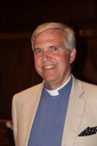 | Thank you for looking at this profile. The person who joins us as our next Team Vicar will be joining this Team Ministry at a very exciting time of challenge, change and development. I have been in post for nearly nine years and together with the ministry team, PCC and other committed church folk we are finding our way forward, following the pandemic lockdowns and the changes that have ensued. We are looking for someone who will journey with us, sharing the leadership as well as participating in the team.  In particular I am looking for a colleague with whom I can be open and with whom I can work closely in building up the Church here. There are exciting opportunities to join us in deciding how to move existing projects forward and develop new initiatives to expand the Kingdom here in Wareham
I would describe my ministry as Biblically based and incarnational. I love to take the love of Christ to the people of the parish and reflect God’s glory wherever I am able. I seek to laugh with those who laugh and weep with those who weep. I believe that all ministry must come from a deep love of the Lord and an equally deep love for those he has called us to serve. The Ministry Profile describes the type of priest that we think we need to complement the Ministry Team at this time.

One other quality that I would love to see in an applicant is a good sense of humour and fun. I think it is important for clergy to enjoy their ministry, and be good news to the people to whom they minister. If Christ came to bring life, and life in abundance, then I think people should know what that looks like, rather than the poor imitation that so many are fobbed off with today!
If you still feel drawn to this post, you will want to read on and discover more about the parish and all that it has to offer. However, if you would like to call me for an informal talk about the benefice please feel free to do so.
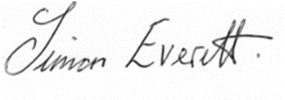
Simon Everett Tel. 01929 289236

Introduction  Wareham is known as the Gateway to the Isle of Purbeck. However the parish not only includes the town but its surrounding villages and hamlets. It is on the edge of an area of natural outstanding beauty but is very much earthed in the reality of twenty-first century life with all its blessings and struggles.  The parish consists of five churches of varying sizes in and around Wareham with assorted worship traditions, set in the beautiful Isle of Purbeck. The five churches are: Lady St Mary, on the southern end of Wareham (pictured on right); St Martin on the Walls, on the northern edge of the town; Sandford St Martin church, which is attached to Sandford Primary School; St Nicholas Arne and St John the Evangelist, East Holme, two outlying villages to the east and southwest of Wareham (respectively). It is situated in the Deanery of Purbeck, which is part of the Dorset Archdeaconry in the Diocese of Salisbury.  We hope that the profile will give a good insight in to all that the parish has to offer and establish that it is an exciting and beautiful place to minister, as well as an area that has great potential for outreach and growth. It also has much to offer a spouse and family by way of employment, schooling and support, should the candidate be married. | 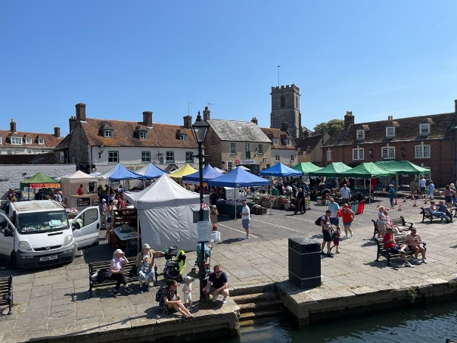
 | 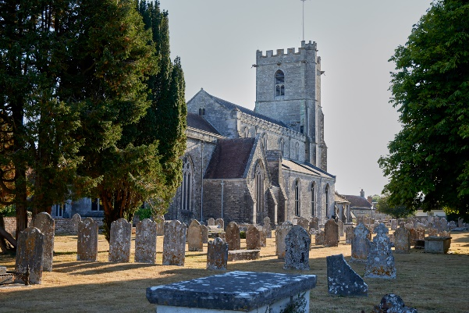
 | 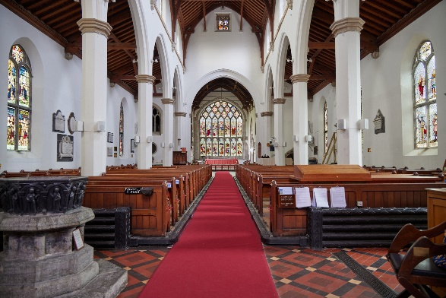

Ministry Profile
First and foremost the new Team Vicar must have a deep love of the Lord and a desire to share the Gospel in word and deed. We want to see someone who is prayerful and open to the promptings and empowering of the Holy Spirit, as well as someone who is excited by the Good News of Jesus and who can pass on that excitement in preaching, teaching and in general conversation.
We are looking for a community minded priest who is an out-and-out team player and who can give strong leadership when required to do so but who shows humility as a team member. Although different members of the ministry team have their own areas of ministry, we seek to prayerfully share what is going on, ensuring we keep one another informed (usually through the weekly Team Meeting and WhatsApp group). In the wider ministry of our churches, we are looking for someone with a commitment to collaboration and creating enabling environments. The Team Vicar will have prime responsibility for the village of Sandford but must be willing to share in the ministry of the wider team. This will be of the utmost importance as the Team Rector will most likely be retiring in the next year or so.
We need someone who is interested in setting up and working with Fresh Expressions, as well as leading traditional liturgical worship. He/she will be expected to take an active part in the pastoral ministry of the parish, taking baptisms, weddings and funerals as required, as well as being involved in civic and community acts of worship. The Team Vicar is also expected to share with other members of the Ministry Team in taking collective worship at the three local church primary schools.
We have a range of ages in our congregations with young families predominantly attending Breakfast Church, based at Sandford St Martin church, and the Family Communion Service in Lady St Mary church, on the first Sunday of the month. There is a real challenge to reach out and attract more young families and teenagers into our churches and/or to share the Christian faith with them wherever they may be. | 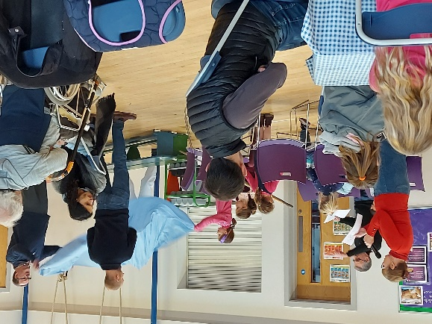
Following the recent lockdowns the parish has developed a popular online YouTube service, that attracts an average of 70 viewers per week. This service is led, and the sermon preached, by a member of the Ministry Team and different members of the congregation record the Bible readings and lead intercessions. Another member of the team then edits and uploads it. However, with our Curates moving on and a Team Vicar vacancy we are exploring the possibility of streaming services live from Lady St Mary church as an alternative.
Prayer is a vital part of our ministry both within the parish and in the wider world. There are a number of prayer groups that meet in church, in homes or online. These include online Ministry Team Morning Prayer twice a week on Tuesday and Thursday mornings. Lady St Mary holds daily prayer for peace at 5pm, and although numbers are small it is a vital way to show our concern for those in Ukraine and other war-torn areas of the world. There is a weekly parish prayer meeting either in person or online and there are more in various homes around the parish. It is expected that the Team Vicar will take an active part in these, as far as is possible.
And it is hoped that our future Team Vicar will seek to encourage and support parishioners in becoming disciples and then help them discover and nurture their vocation.

Finally, we sincerely look forward to the successful applicant bringing their own gifts and experience to the role, in order that we continue to broaden and grow. In turn we would hope that he/she will be open and eager to learn in their new setting, and to engage with the on-going Continuing Ministerial Development provided by the diocese.
Our Mission
As a church we seek to reach out to all our parishioners with God’s love, being led by the Holy Spirit. All that we do is undergirded with prayer and a desire to please God and reflect his glory to the world around. We place an emphasis on all Christians being salt and light in the parish and beyond, using the talents and gifts that God has given them. We want non-Christians to see the difference that knowing Jesus makes and pray that they will be intrigued to know more.
We have run Alpha courses and other small groups to which we invite those exploring Christianity and those who wish to deepen an existing faith. Following the completion of these courses we aim to introduce them into home groups.
Other ways in which we reach out is by drawing alongside those who come to us for the occasional offices, or with any kind of need. We seek to welcome those who are new to the area, helping them integrate and feel at home.
The PCC Vision statement for the Parish of Wareham is as follows:
‘Our Vision for the parish is to show God’s love and to make Jesus known. We seek to fulfil our vision by reaching out to our local community in the power of the Spirit, in whatever way we can. This includes prayerfully serving those in need whilst enjoying fellowship together. And as we do this we hope to grow as disciples of Christ all the while feeding on God’s word.’
In order to cover the many areas of parish life the PCC has appointed seven sub-committees (as well as each church having its own committee), these report to the PCC. They are as follows:
- Children and Youth  - Environment and Eco Church Committee  - Fabric Committee  - Finance Committee | - LSM Re-ordering and New Hall Committee  - Mission Committee  - Parish Hall Committee
In addition to the clergy we have a part-time Parish Administrator and seven Lay Pastoral Assistants who assist with visiting and taking communion to the sick and housebound, offering support to the bereaved, supporting baptism families, leading home groups, working with children and assisting with services both in church and at local care homes.
Many church members volunteer on teams which include welcomers, tea and coffee rotas, operation of the AV systems, Church Guides, assisting in the Church Office and children and youth work.
How we see our strengths -
- We have a reputation for being a welcoming parish and have wide pastoral contacts in terms of Baptisms, Weddings, Funerals, and care for the sick and bereaved.
- We have Christian outreach to the three church school assemblies and clubs, with some 600 children each week.
- We enjoy different approaches to worship so that whilst we treasure our traditions, we also embrace contemporary worship.
- We have a strong desire to see Christ’s church grow here in this parish and seek to spread the gospel in word and deed.

The Deanery
‘Purbeck Deanery is a relatively small deanery with four benefices. Two of these are centred on Swanage and Wareham, each with a team rector and team vicar, and the other two are the multi parish benefices of West Purbeck and St Aldhelm, each with an incumbent and associate clergy. The Chapter meets most months for sharing of concerns and news, and any business with occasional visiting speakers; a couple of gatherings are of a more social, light-hearted nature. It is a friendly and supportive deanery.
The Deanery Synod usually meets three times a year and usually has a visiting speaker with this part of the meeting taking place first and open to anyone in the deanery. The new synod will be looking for a lay chair and treasurer, and I will myself be retiring in the autumn. Although, inevitably, people in the deanery focus on their own benefices and communities there is a willingness to get to know each other and support where possible and appropriate.’
The Reverend Ian Jackson – Rural Dean of Purbeck
Ecumenism
Within Wareham and the deanery there are various expressions of ecumenism. Many of the different church leaders meet for lunch each month to share and pray for one another. This takes a very charismatic form and often visions and words are shared and interpreted. The Wareham Church Family meets a couple of times a year and joined for a walk of witness on Good Friday as well as joint service in January at the start of the week for Christian Unity. Over the past couple of years there has also been a summer gathering for a Church Family picnic.
The Geography of the Parish
The ancient market town of Wareham is located between the rivers Piddle and Frome on the west side of Poole Harbour and about nine miles from Poole town centre and within easy reach of Bournemouth and Dorchester. It is the Gateway to the Isle of Purbeck and the A351, which bypasses the town centre, leads on to Corfe Castle and Swanage. The history of the town dates to pre-Roman times and in due course Wareham became an important Saxon port. The region has a thriving tourist economy, extensive farmlands and a diversity of high and low technology industry.  Wareham has a large selection of independent shops including bakers, butchers, clothes shops, a health food store, a zero-waste shop, a hardware shop and three small supermarkets. As a tourist centre it has a large selection of art and craft shops, restaurants, cafés and public houses. | 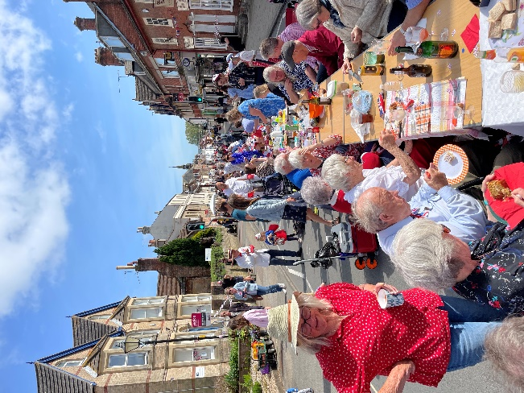  Coronation Street party
There is a health centre in Wareham and another one in Sandford together with three pharmacies and two dentists. The previous cottage hospital still holds outpatient clinics and has been used as the Covid vaccination centre for the area. There are plans to build a new health centre. The area is served by hospitals in Poole, Bournemouth and Dorchester. There are three church primary schools in Wareham, Stoborough and Sandford and a secondary school. All four schools have received ‘Good’ Ofsted reports within the last year. There is a thriving leisure centre with an indoor swimming pool adjacent to the secondary school and an independent cinema showing the latest releases. The community spirit is strong with regular festivals, live music, arts events and carnivals.
Housing is relatively expensive in Wareham as the area attracts those retiring from work in other areas of the country. Following the pandemic the area is also attractive to those who can work from home as it has easy access to London with a direct rail link. The population includes newcomers but also there are a number of families who have lived here for several generations. A few properties are second homes or holiday rentals, but this is not extensive.
Being close to the coast and Purbeck Hills there are plenty of opportunities to enjoy water sports, walking and cycling. There are active Rugby and Football clubs and several good golf courses nearby.
There are two trains an hour from Wareham to London Waterloo or to Weymouth. There are hourly buses to Poole or Swanage and coach links to further afield.

The Parish
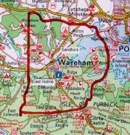 | The Benefice of Wareham includes the outer villages of Stoborough, Ridge, Arne, East and West Holme, Sandford, Holton Heath and Organford. The total population of this area is around 11,000 of whom some 6,000 live in Wareham town (including Northmoor, Northport and Carey). Some 31% of the population are aged over 65 compared to 19% of the population of England and Wales as a whole. 16% are aged 0-15 years compared with 19% of the population of England and Wales. Over 90% of the population are white British.
There are few areas available for new housing development in Wareham as the town is surrounded by river floodplains and areas designated as nature reserves, forest or sites of special scientific interest. The Wareham Neighbourhood Plan for 2021 estimates that a total of 305 new homes could be built in the period 2019-34, with the largest number on the middle school site off Worgret Road.
The church community is well represented on the Town Council and in businesses, charities, community activities and schools. The churches are used for civic events and concerts. The Parish Hall is used by many organisations for social events, exercise classes and local clubs and helps generate income for church finances.
In 2012 the parish helped start a Community Café – ‘Not Just Sundaes’ in a redundant church on South Street. This has a Christian ethos and provides space for different groups that provide support to vulnerable adults as well as welcoming residents and visitors to the town for refreshments and light lunches. Two of our clergy are involved as Trustees and the Revd. Hilary Bond is based in the café one day each week. Not Just Sundaes also houses a Community Fridge that distributes out-of-date food and provides some tourist information. | 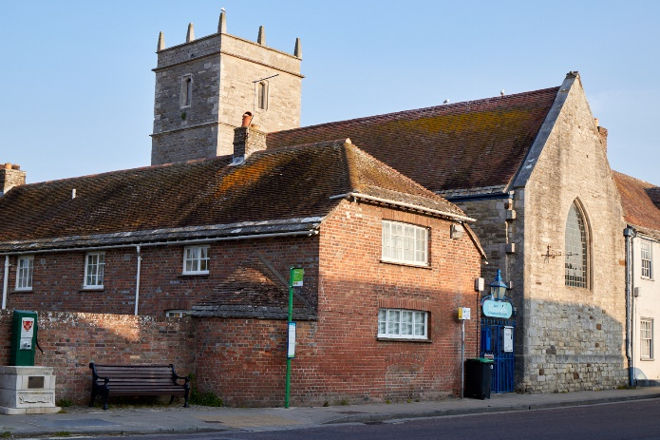
The Parochial Church Council acts as the Trustees of the legal parish charity and comprises members from all the churches and from the Ministry Team. It meets about six times each year but has various sub-committees and individual committees for each of the five churches.

Finance
Although we have been able to pay our diocesan share for the past decade, we have like other parishes found this a challenge. With a parish membership of 314 our Share payment for this current financial year is £117,415, this coupled with the maintenance of four listed historic church buildings and maintaining an active ministry within the parish, raising the necessary capital is a challenge. This said, we believe that the Lord provides for His ministry, and it has been wonderful to witness how he has done this over the past few years.
Many parishioners give generously through monthly or quarterly standing order with the Parish Giving Scheme, although there are a few of the older generation who give via weekly envelopes. We also hold an annual Gift Day at which parishioners can make further donations towards the mission and ministry of the church. Other income streams include parish hall and church hire, legacies, clergy fees and donations from visitors. The churches also come together for various fundraising events throughout the year, that can be both fun and profitable.
Mission support abroad and at home
The Parish supports overseas missionaries in two countries: Ruth Guinness with SIM in Malawi and Malcolm and Yanet Taylor with their two children with YWAM in the Dominican Republic. Both Ruth and Malcolm have parents living in Wareham who are members of our churches.
We have an active link with St Stephen’s School, Terekeka, South Sudan through the Salisbury Diocesan link with the Sudans. Our link with St Stephen’s goes back to 2005. We provide financial support for teachers’ salaries, building work and purchase of resources. Members of the church have visited Terekeka in 2012 and 2020. We were also pleased to welcome Bishop Paul Modi (Bishop of Terekeka) and his wife Mama Edina to Wareham for four days in August 2022 following the Lambeth conference. | 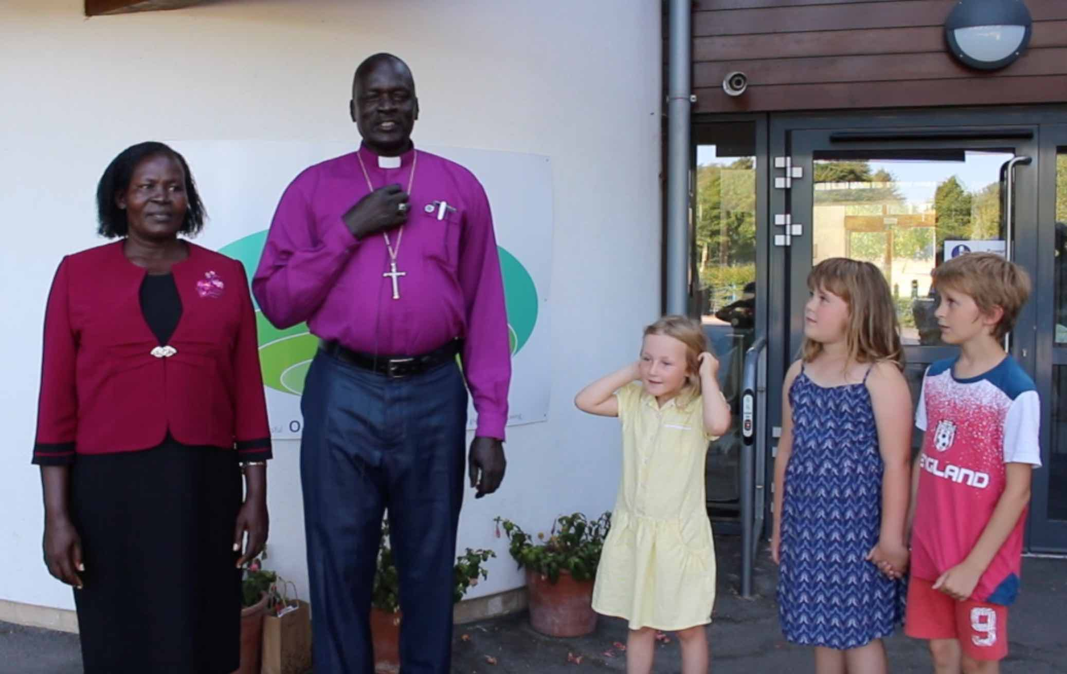  Bishop Paul and Mama Edina at Sandford School
We also support the Mission to Seafarers. There is an annual Mission Sunday when we provide an opportunity for people to give financially to support our mission partners.
Nearer to home, with the pandemic and cost of living crisis there has been an increasing demand for help from parishioners to make ends meet. We are fortunate to have two charities which can give financial assistance to those in need – The Blessing Fund and the Wareham Relief in Need and Sickness Charity, both have been kept busy the past couple of years. Also, with the massive increase in utility prices we were able to provide two warm spaces in Not Just Sundaes and Lady St Mary church, both of these provided welcome warmth during the winter months.
The parish is blessed with a community food bank that is run by the Purbeck Gateway church and generously supported by the local community. Wareham is a Fairtrade town and the parish churches have agreed to support this by buying only Fairtrade products.

The Ministry Team
Team Rector  Canon Simon Everett | 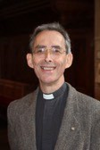  Associate Priest (SSM)  The Revd Michael Young | 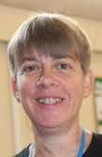  Associate Priest (SSM)  The Revd Hilary Bond
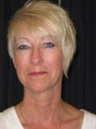  Parish Administrator  Mrs Debs Barclay | 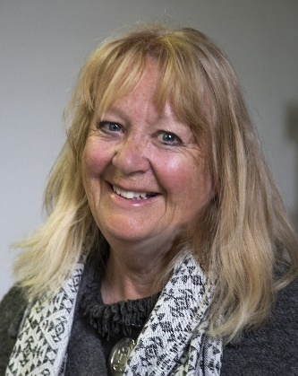  Churchwarden  Mrs Hilary Goodinge | 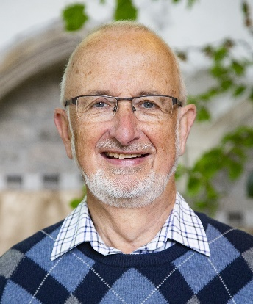  Churchwarden  Mr Mike Quinlan
The Ministry Team meet weekly for prayer and to discuss parish matters.
The Team Vicar’s House
Sandford Vicarage is located in the heart of the village, it is a four bedroomed house with gas-fired central heating situated in large, wooded grounds. There is ample parking at the front of the house. The downstairs front entrance contains a WC and a separate entrance to the study. The rest of the downstairs contains a large lounge, kitchen, utility room and dining room. Upstairs are three double bedrooms and one single, a bathroom with bath and shower and separate WC. The kitchen was renewed in 2022 and the front and rear doors have been recently replaced with UPVC to reduce draughts. | 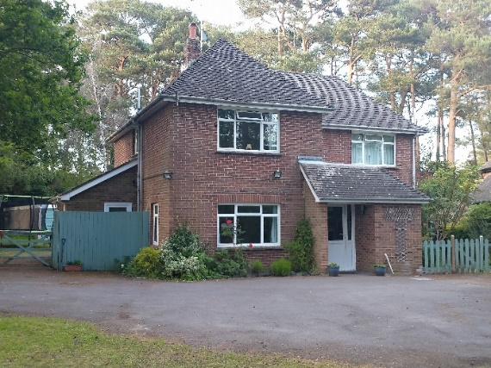
The back garden contains a garden shed, garage, summerhouse and large treehouse. The Vicarage is approximately two and half miles from the centre of Wareham and eight miles from Poole town centre, with cycle paths available to both. There is a petrol station with an attached Co-op store nearby and a GP practice and pharmacy, a public house and a Nepalese restaurant. Wareham Railway station is just two miles away and there is a bus stop at the end of the road with hourly buses to Wareham and Poole.
Sandford St Martin’s Primary School (http://www.sandfordprimary.dorset.sch.uk) is only two hundred and fifty metres away with a choice of two secondary schools: Lytchett Minster School (http://www.lytchett.org.uk) and Purbeck School (http://www.purbeck.dorset.sch.uk) within a three and half miles radius. There are also Grammar schools in Poole and Independent schools in the area.
Sandford
The parish of Sandford has been part of the Wareham parish for over three decades and has always been the location of the Vicarage. It has an interesting history and was once well known for its clay potteries. In recent years it has expanded with many new houses being built and although most working residents commute to Poole, Bournemouth, Dorchester or local army camps, it still retains its own identity. It has a population of nearly 3,000.
Until the beginning of 2015, the church was in an adjoining building to the old first school. However, when the Local Authority decided to change from a three to two tier education system it was recognized that there was not room for this school to expand. And so a new build was proposed on the site of the then middle school. The decision was made by the Ministry Team and PCC that the church should retain its link with the school and that a new church be built as part of the new primary school. The new church has very good links with the school and the school hall is used for Breakfast Church and other larger services. The school also uses the church space for occasional meetings. The Team Vicar has served as a governor of the school.
The children started at the new Sandford St Martin’s Primary School in September 2014, and the move from the old church to the new Worship Centre took place in February 2015. This was followed by an official dedication service in June 2016, conducted by the Bishop of Sherborne.
The old church building is now run as a Heritage Hall by the Parish Council and is in the grounds of Pine Martin Grange, a 64-bed nursing and dementia Care Home, which was built on the old first-school site. The church has close links with Pine Martin Grange. Some residents attend our services, and we hold a monthly service in the Care Home.
Our Buildings
Sandford St Martin’s Church  This is the most recent worship space within the Parish and is attached to a new Church of England Primary School building, replacing an old school and worship centre one hundred metres down the road. This hosts weekly Breakfast church followed by a more traditional service.  Occasional outdoor services are held in the school fields adjacent to the church and this was particularly popular as we emerged from lockdowns in 2020 and 2021. | 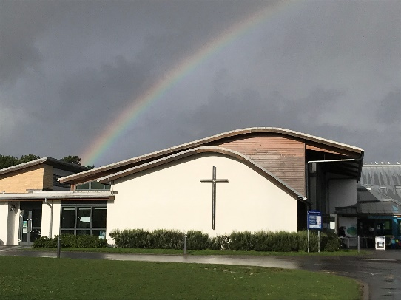
 | 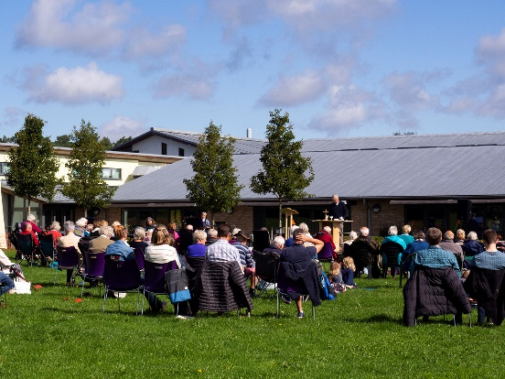

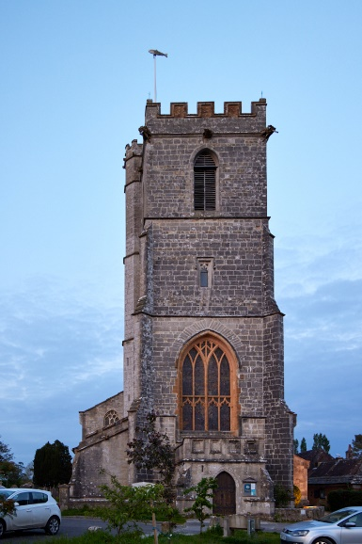 | Lady St Mary Church, Wareham  This ancient priory church has its origins dating back to Saxon times. It was substantially modified in Victorian times but retains some medieval (and earlier) features including the St Edward Chapel, a semi-sunken secluded side chapel used for prayer groups and small services. The main part of Lady St Mary provides us with our largest worship space and is used every weekend, it is also where the majority of baptisms, weddings and funerals take place. As well as Church services it is also used for concerts and recitals. The audio-visual system and screen have been used more extensively since lockdown giving a greater flexibility in worship and for other functions.

St Nicholas’ Church, Arne  Here is a small church that currently provides a more traditional (BCP) form of worship. Very few live within the immediate vicinity nevertheless a healthy congregation, drawn from a wide area, gathers every other Sunday for Holy Communion. | 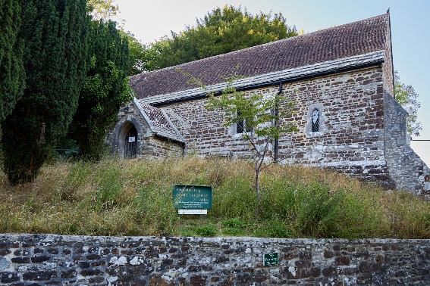

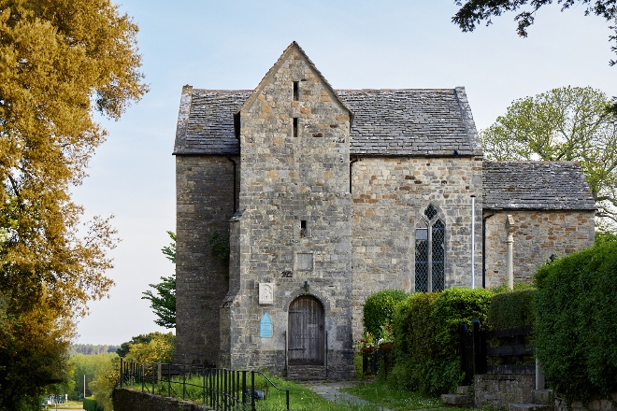 | St Martin on the Walls, Wareham  This is one of the oldest churches in Dorset and was built in approximately 1020. It is well known for two different reasons: firstly it contains some very early medieval wall paintings telling the story of St Martin and secondly, it houses an effigy of Lawrence of Arabia, attracting many visitors throughout the year but particularly in the summer. But more importantly it has a small but faithful congregation who meet each Wednesday for BCP Holy Communion.

St John the Evangelist, East Holme  This lovely little parish church is situated within the private estate of East Holme Priory. Set in a very rural location, well off the beaten track, it has recently celebrated its 150th anniversary. The inside was beautifully decorated by the lady of the manor and provides a small parish church for the local community. | 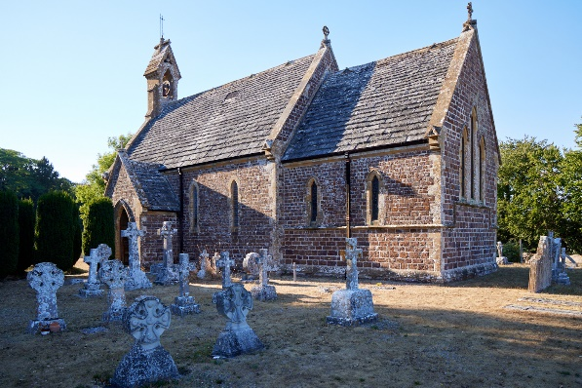

Eco Church and the Environment
Two of our churches (Lady St Mary and East Holme) have gained A Rocha environmental Bronze awards. And to encourage more parishioners to think about green ideas there is rota for writing green tips for the weekly pew sheet.  Recently there have been churchyard surveys for Lady St Mary’s and Arne. Across both sites 251 different species were recorded. In LSM alone there were 19 species of bird, 3 types of ferns, 95 different flowering plants, 5 species of insects and 10 varieties of fungi. Some of the members of the Sustainable Wareham group helped with the surveys and this led to a very positive write up in their September newsletter. Also, as a result of the finding the Wareham Burial Joint Committee have agreed to change the mowing regime for part of the Lady St Mary Churchyard in order to encourage biodiversity | 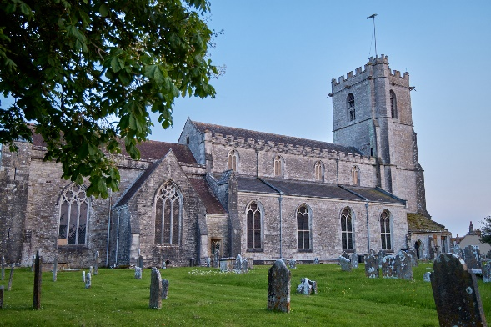
 | 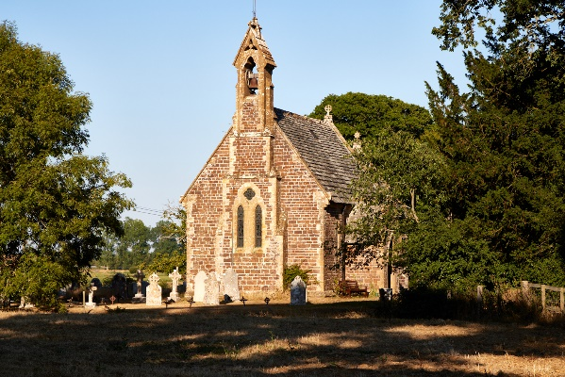
The Church Services - current pattern
Church |  | 1st Sunday | 2nd Sunday | 3rd Sunday | 4th Sunday
Lady St Mary | HC BCP  HC CW | 08:00  10:00  (Fam HC) | 08:00  10:00 | 08:00  10:00  (Praise  Communion) | 08:00  10:00
St Nicholas, Arne | HC BCP | 10.30 |  | 10.30
St John,  East Holme | HC BCP  Evensong  BCP |  | 10.00 |  | 10.00 HC Winter  18.00 Evensong  Summer
Sandford St Martin’s | Breakfast Church  HC/MP - CW | 09.00  10:30 MW | 09.00  10:30 HC | 09.00  10:30 MW | 09.00  10:30 HC
St Martin  on the Walls | BCP Holy Communion 11.00am every Wednesday
When there is a fifth Sunday to the month, we hold a united service where all five churches gather under one roof. Sometimes a guest preacher is invited to this service.

Baptisms, Weddings and Funerals
Thanksgivings / Baptisms / Renewal of Baptism Vows / Confirmation
We prefer to hold Baptisms and Thanksgivings within our main Sunday acts of worship, although occasionally it is necessary to hold them at other times. These are aways held after the candidate or family have had a time of preparation, first by the clergy and then by one of our Lay Pastoral Assistants. The number of baptisms conducted varies year on year, but the number of thanksgiving services remain small.
Weddings and Renewal of Vows  We are always happy to welcome wedding couples who are resident or who have a qualifying connection with the parish. In recent years the number of weddings held in the church has declined (in line with the national trend), but we are hopeful that this may change. A Marriage Preparation Day is held each February for the couples who will be married later in the year. Over recent years we have seen an increase in the number of couples wishing to renew their weddings vows, often on the occasion of an anniversary. | 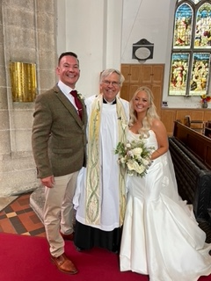
Funerals and Memorial Services
It is our privilege to come alongside people with the love of Christ during times of grief. Our clergy hold services in church, at the local crematoria (usually Poole but occasionally Bournemouth, Weymouth or Salisbury) and at local burial grounds. During 2022 our clergy team were present at 54 funerals.
Also, on the first Sunday of November each year we hold an All Souls service for those who have been bereaved. This is a much-valued part of our ministry, particularly post-pandemic.

Music and Choirs  Lady St Mary Church has a robed, four-part choir affiliated to the RSCM. It also participates in diocesan activities and in the annual Choirs’ Festival. There is a sung Eucharist on the second and fourth Sundays of the month, but the choir also assist with the Family Communion and the Praise Communion. The Praise Communion was introduced relatively recently as a way to introduce the congregation to some more modern worship songs, accompanied by a worship Group. The choir also sing for an Advent Service of Light, a Carol Service and Candlemas Evening Prayer. | 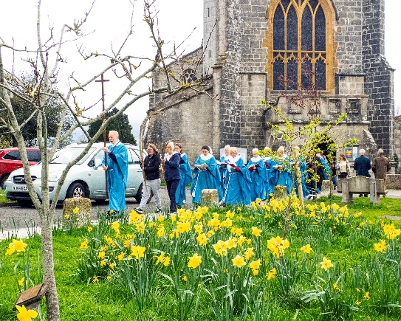
Breakfast church at Sandford St Martin church has informal worship whereas the 10.30am service is more traditional.

Youth and Children’s Groups
The parish runs two toddler groups, in the Parish Hall on Thursdays and in Sandford church on Tuesdays. Numbers are high at the Parish Hall and activities include songs, craft and a spiritual message. The current themes are miracles and being thankful. In Sandford the numbers are lower and consideration is being given to change this to a simpler coffee morning, possibly linking with the work being done by the school in supporting local families.
Angel Voices is going from strength to strength with 17 regular attendees. They sing together in the Parish Hall from 9.15am on the first Sunday of the month and then walk over to the church to join the service. From the age of 10, children are invited to join the handbell group which practise beforehand and then join in with worship at 10am.
A small but dedicated youth group for 11–13-year-olds meets weekly in term-time to explore their faith together using activities and discussion. Recently the group has acted in, shot and edited two videos which were shown in church at Christmas and Easter.
Friday Night Youth has been running for a year at Sandford School and is a drop-in youth club for ages 10-13. It attracts around 40 children each week in term-time and includes crafts and games, both indoors and outdoors when weather and time of sunset permit. Out of this group we are taking about 15 young people in late June to Spree South West, a Christian camping and activity week run by Urban Saints and South West Youth Ministries.
Church Visitors
It is estimated about 9,000 visitors a year visit Lady St Mary Church, some arriving by boat from Poole or from visiting coach parties. Various displays and leaflets inform these of the history and features of the church. At certain times of the day local volunteers act as guides to welcome and talk about the church, its life, ministry and mission as well as the building itself. We are intending to improve the entrance and west end of the church as part of a re-ordering project, which we hope will draw even more people into the church, both visitors and worshippers.
St Martin on the Walls draws hundreds of visitors a year. Plans are afoot to put in a new heating and lighting system as well as making it a more welcoming worship space and tourist destination.
St Nicholas Church, Arne attracts those who come to the RSPB nature reserve and is open every day for visitors.
Bell ringers  Lady St Mary has a peel of 10 bells and a band of 14 ringers and 10 learners and is affiliated to the Salisbury Diocesan Guild of Ringers. We ring for the 10.00am Parish Communion and have a weekly practice night. We joined together to ‘Ring for the King’ on the day of the Coronation. | 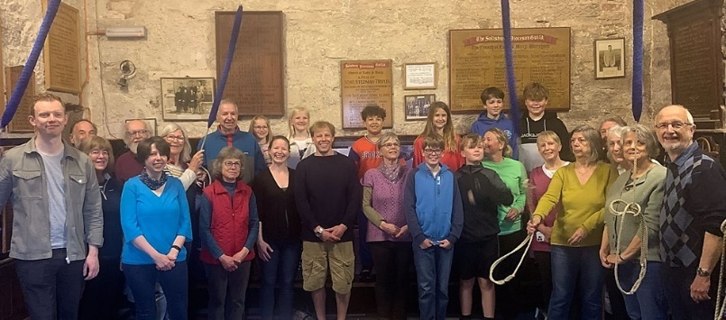
Home Groups
There are six small groups consisting of some 50 people who meet at different times and frequencies. Recently it has been a struggle to find people willing to lead, which is a shame as there are people waiting to join. It is hoped that the new Team Vicar will help co-ordinate these groups and inject new life where necessary!
Schools
Wareham has three Church of England primary schools and a large secondary school, all of which are open to church involvement through direct contact with the children and supporting roles such as being a school governor. The new Team Vicar will be a Foundation Governor at Sandford St Martin’s CE VA Primary School.
Our ministry in the primary schools is much appreciated. The Foundation Governors work hard to provide support for the staff and a careful steer on maintaining the Christian ethos. There is also a great opportunity for the clergy to provide pastoral care for the staff.
We lead Collective Worship in all three Primary Schools as well as lunchtime and after school clubs and class sessions on specific parts of the curriculum. Until recently our Pioneer Priest Hilary Bond was also our honorary Schools Worker but she has now branched out into other areas of ministry. However, in the summer a new Team Vicar will join the Swanage Team who will also have a remit to work with the schools in the deanery.
The schools regularly come to Lady St Mary church and the Sandford Worship Centre as part of their learning, and now regularly invite the clergy to support them in their curriculum requirements and the life of the school community.
We have also run special sessions and services on Christmas, Easter, following Jesus and God, and looking after the environment, amongst others.
Men’s Breakfast  This meets monthly, with a varied programme of guest speakers and inhouse talks/discussions. It is held in Not Just Sundaes and attracts between a dozen and twenty men. | 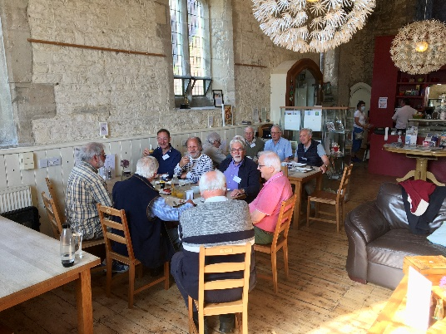
Women that Lunch and Pray + Ladies Walking Group
This meets once a month and is held in the Rectory. It does what the name suggests although there is often a guest speaker who will either speak on prayer and spirituality or lead a meditation. Some of the fitter members of this group also venture out once a month for a walk in the Purbeck Hills, this is also part of our qualifying for the Eco Church award.
Alpha and Lent Courses
In recent years the parish has held outreach and growth course, usually in the form of the Alpha Course, which has proved popular, with some coming to a committed Christian faith and others refreshing and deepening an existing faith. When appropriate these act as part of a confirmation course, supplemented by further teaching on the Church and the sacraments. Each Lent there is a Lent course that the whole parish follows. Some meet as home groups but others prefer to gather in the parish hall for a larger meeting. This proves a popular way for the parish to grow together in faith and fellowship.

Saturday Coffee
Every Saturday the parish hall is full of people coming together for coffee and catching up with others. The ministry team is there to meet people and help them with problems and questions, if required. This is also market day and so there is a good opportunity to meet with traders and shoppers alike on the quay.
Times Away
Prior to the pandemic we held biannual weekends away for church members at a Christian hotel or conference centre and there is a possibility that these could be re-started in the future. There is an annual pilgrimage organised by one of our church members visiting Cathedrals and Stately Homes in different areas of the British Isles. In 2022 this included a trip to see the Passion Play at Oberammergau with a week in the Austrian Tyrol. A group of 18 including children are going to United 23 run by New Wine in Kent in August 2023.
By way of Conclusion
We hope that you have enjoyed reading this Wareham Team profile. This document gives an outline sketch of the life, ministry, mission and workings of the parish but there is so much more to be discovered. However, if it has caught your imagination and given you a holy interest to know more, then please do make contact and come and see us or complete an application form.

Further information can be found on our website:
www.warehamchurches.org.uk

